Movie Moguls – Classic Hollywood

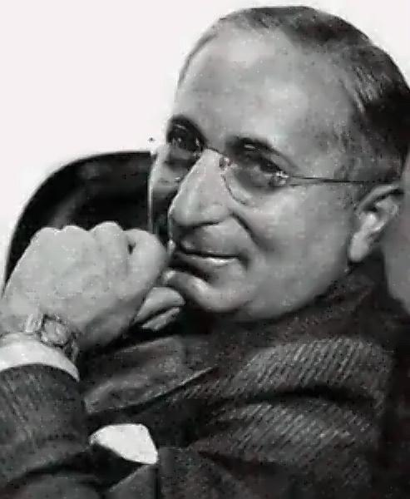
Louis Burt Mayer (born Lazar Meir July 4, 1884 – October 29, 1957) was a Russian-born American film producer. He is generally cited as the creator of the "star system" within Metro-Goldwyn-Mayer (MGM) in its golden years. Known always as Louis B. Mayer and often simply as "L.B.", he believed in "wholesome entertainment" and went to great lengths so that MGM had "more stars than there are in the heavens". s a studio boss, Louis B. Mayer built MGM into the most financially successful motion picture studio in the world and the only one to pay dividends throughout the Great Depression of the 1930s. However he frequently clashed with production chief Irving Thalberg, who preferred literary works over the crowd-pleasers Mayer wanted. He ousted Thalberg as production chief in 1932 while Thalberg was recovering from a heart attack and replaced him with independent producers until Thalberg's death in 1936, when Mayer became head of production as well as studio chief. Under Mayer, MGM produced many successful films with high earning stars, including Greta Garbo, Clark Gable, Spencer Tracy, Katharine Hepburn, Lon Chaney, Joan Crawford, Jean Harlow, Judy Garland and many others.
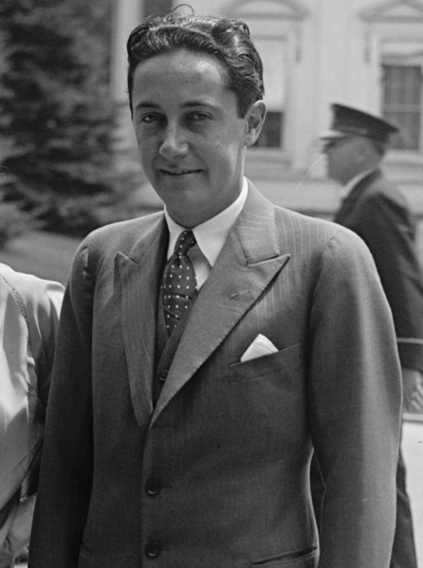
Irving Grant Thalberg (May 30, 1899 – September 14, 1936) was an Academy Award-winning American film producer during the early years of motion pictures. He was called "The Boy Wonder" for his youth and his extraordinary ability to select the right scripts, choose the right actors, gather the best production staff, and make very profitable films. Thalberg's name appeared on the screen in only two of the pictures he produced, both of which were completed after he died. While he was alive, he refused to allow his own name to appear in his films. The credit for his final film, The Good Earth (1937) reads: "To the Memory of Irving Grant Thalberg his last greatest achievement we dedicate this picture." Another dedication to him appeared in the opening credits of Goodbye, Mr. Chips (1939), a film that Thalberg set into motion, but never lived to see.
Thalberg, a good friend of the Marx Brothers and responsible for saving their careers, once sent this often-repeated quote to Groucho Marx via letter on the latter's birthday: "The world would not be in such a snarl, if Marx had been Groucho instead of Karl."
In 1938, the multi-million dollar administration building built on the old MGM Studios in Culver City – now Sony Pictures Studios – was named for Thalberg. The Irving G. Thalberg Memorial Award, presented by the Academy of Motion Picture Arts and Sciences, is also named for him.

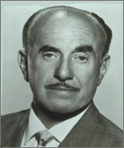
Jack Leonard "J.L." Warner (August 2, 1892 – September 9, 1978), born Jacob Warner in London, Ontario, Canada, was the president and driving force behind the successful development of Warner Bros. Studios in Hollywood, Los Angeles, California. Warner's 45-year career was lengthier than that of any other traditional Hollywood studio mogul.
As co-head of production at Warner Bros. Studios, he worked with his brother, Sam Warner, to procure the technology for the film industry's first talking picture. After Sam's death, Jack clashed with his surviving older brothers, Harry and Albert Warner. He assumed exclusive control of the film production company in the 1950s, when he secretly purchased his brothers' shares in the business after convincing them to participate in a joint sale of stocks.

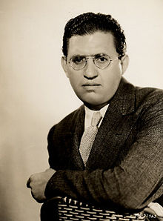
David O. Selznick, born David Selznick (May 10, 1902–June 22, 1965), was one of the iconic Hollywood producers of the Golden Age. He is best known for producing the epic blockbuster Gone with the Wind (1939) which earned him an Oscar for Best Picture. Not only did Gone with the Wind gross the highest amount of money in the U.S. domestic box office of any film ever (adjusted for inflation), but it also won seven additional Oscars and two special awards. Selznick also won the Irving G. Thalberg Memorial Award that same year. He would make film history by winning the Best Picture Oscar a second year in a row for Rebecca (1940).

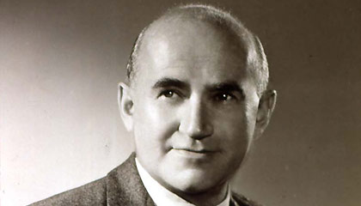
Samuel Goldwyn (ca. July 1879 – 31 January 1974) was an American film producer, and founding contributor executive of several motion picture studios. Famed for his relentless ambition, bad temper and genius for publicity, Samuel Goldwyn became Hollywood's leading "independent" producer -- largely because none of his partners could tolerate him for long. Goldwyn himself was ousted from his own company before the merger, which was why his name became part of MGM even though he himself had nothing to do with the company. After his firing Goldwyn would have nothing to do with partners and went into independent production on his own, and for 35 years was the boss and sole proprietor of his own production company, a mini-studio specializing in expensive "quality" films, distributed initially by United Artists and later by RKO. His contract actors at various times included Vilma Bánky, Ronald Colman, Eddie Cantor, Gary Cooper, David Niven and Danny Kaye. In some cases, Goldwyn collected substantial fees for "lending" his stars to other producers. Touted by publicists for his "Goldwyn touch" and loathed by many of his hirelings for his habit of ordering films recast, rewritten and recut, Goldwyn is best remembered for his films that teamed director William Wyler and cinematographer Gregg Toland.

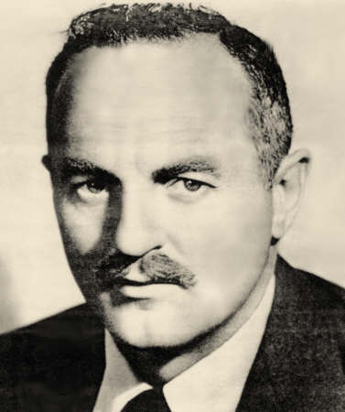
Darryl Francis Zanuck (September 5, 1902 – December 22, 1979) was a producer, writer, actor, director, and studio executive who played a major part in the Hollywood studio system as one of its longest survivors (the length of his career being rivalled only by that of Adolph Zukor). In 1933 he left Warners to found 20th Century Fox with Joseph Schenck and William Goetz, releasing their material through United Artists. In 1935 they bought out Fox studios to become 20th Century Fox. Zanuck was vice-president of this new studio and took an interventionist approach, closely involved in editing and producing. During the war he worked for the Army.
As with so many other moguls, extramarital encounters were a daily ritual with Zanuck. In his 1984 biography of Zanuck, Leonard Mosley claimed headquarters would shut down every afternoon between 4:00 and 4:30pm for Zanuck's 'amourous' activities. According to dozens of Zanuck's contemporaries, employees, and the women themselves, every single day at four some beautiful young girl on the lot was led into his office like a Christian to the lions. If they denied him their careers were doomed.
In the 1950s, he withdrew from the studio to concentrate on independent producing in Europe. He left his wife, Virginia Fox Zanuck, in 1956 and moved to Europe to concentrate on producing. Many of his later films were designed in part to promote the careers of his successive girlfriends, Bella Darvi, Irina Demick and Geneviève Gilles, and several movies he produced featured his girlfriend of moment, including French singer Juliette Gréco.
He returned to control of Fox in 1962, replacing Spyros Skouras, in a confrontation over the release of Zanuck's production of The Longest Day as the studio struggled to finish the difficult production of Cleopatra. He made his son Richard D. Zanuck head of production. He became involved in a power struggle with the board and his son from around 1969. In May 1971 Zanuck was finally forced from "his" studio.

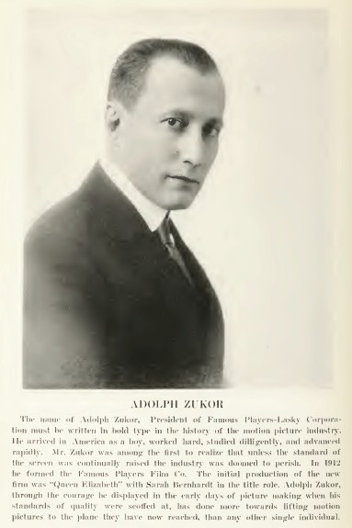
Adolph Zukor, born Adolph Cukor, (January 7, 1873 – June 10, 1976) was a film mogul and founder of Paramount Pictures. Aadolph Zukor's success began with penny arcades, offering moving peepshows that evolved into nickelodeon theaters that offered longer, larger moving pictures. On July 12, 1912, he premiered the first feature-length film, Les amours de la reine Élisabeth (1912), featuring French actress Sarah Bernhardt that ran for 40 minutes. From exhibition Zukor moved into production, and eventually consolidated several smaller companies into what we know today as Paramount Pictures Corporation. In 1914 he produced the first American-made feature film, The Prisoner of Zenda (1913), and that was followed by such successes as The Count of Monte Cristo (1913), Tess of the D'Urbervilles (1913), The Sheik (1922) and The Covered Wagon (1923). He was also credited with personally bringing to the screen some of the industry's great stars.

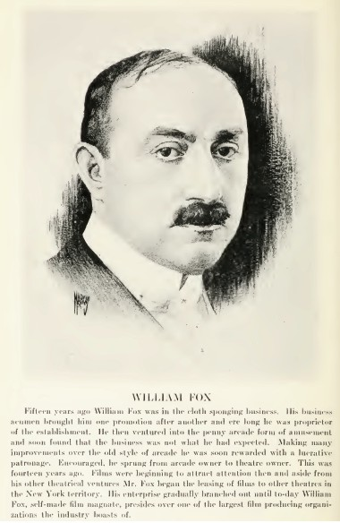
William Fox (January 1, 1879, Tolcsva, Austria-Hungary – May 8, 1952, New York City), born Wilhelm Fried (Hungarian: Fried Vilmos), was a pioneering American motion picture executive who founded the Fox Film Corporation in 1915 and the Fox West Coast Theatres chain in the 1920s. Although Fox sold his interest in these companies in a 1936 bankruptcy settlement, his name lives on as the namesake of the FOX Television Network and the 20th Century Fox film studio. He was among the pioneers of the motion-picture and entertainment industry.

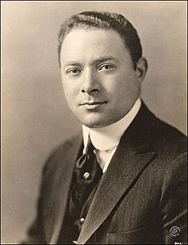
David Sarnoff (Russian: Давид Сарнов, February 27, 1891 – December 12, 1971) was a Belarusian-born Russian-American businessman and pioneer of American commercial radio and television. He founded the National Broadcasting Company (NBC) and throughout most of his career he led the Radio Corporation of America (RCA) in various capacities from shortly after its founding in 1919 until his retirement in 1970.
He ruled over an ever-growing telecommunications and consumer electronics empire to include both RCA and NBC, which became one of the largest companies in the world. Named a Reserve Brigadier General of the Signal Corps in 1945, Sarnoff thereafter was widely known as "The General."
Sarnoff is credited with Sarnoff's law, which states that the value of a broadcast network is proportional to the number of viewers.

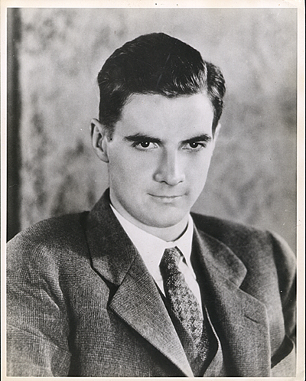
Howard Robard Hughes, Jr. (December 24, 1905 – April 5, 1976) was an American aviator, engineer, industrialist, film producer, film director, philanthropist, and one of the wealthiest people in the world. He gained fame in the late 1920s as a maverick film producer, making big budget and often controversial films like Hell's Angels, Scarface, and The Outlaw. Hughes was one of the most influential aviators in history. He also set multiple world air-speed records (for which he won many awards, including the Congressional Gold Medal), built the Hughes H-1 Racer and H-4 "Hercules" aircraft, and acquired and expanded Trans World Airlines. Hughes is remembered today, however, for his eccentric behavior and reclusive lifestyle in later life, caused in part by a worsening obsessive–compulsive disorder

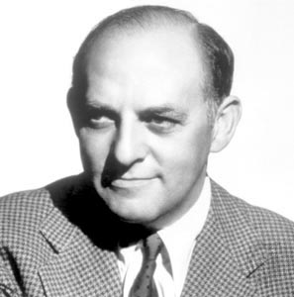
Harry Cohn (23 July 1891 – 27 February 1958) was the American president and production director of Columbia Pictures. He was crude, uneducated, foul and, even on his best behavior, abrasive. No major studio executive of the so-called Golden Age was more loathed (although at times the dictatorial Samuel Goldwyn and hard-nosed Jack L. Warner came close) than Harry Cohn. Born in the middle of 5 children to Joseph Cohn, a Jewish tailor and Bella, a Polish émigré, Harry was raised on New York's rough lower class East 88th Street where he followed his older brother Jack Cohn into show business. Harry's life and the origins of Columbia Pictures are closely associated with Jack, whose early career paved the way for his own ambitions, despite the fact that the two brothers fought bitterly and each harbored deep resentment over the other's success.

