**POST PRODUCTION AUDIO GUIDE – AND SPECS**

**Audio post production** is laborious and time-consuming. To the uninspired it is also tedious. No matter what, it is necessary.

This quick guide covers a lot of ground. It tries to explain the process of audio post production, the workflows involved, and their importance in the overall scheme of things.

Audio post production for Film can be broadly divided into six major steps:

**Specs –** Determine the projects Specifications

**Recording** – Recording Foley, ADR, Atmos, Sound FX, Wild takes, etc.

**Media Management/Work Flow** – Work Flow Charts/Sheets, Naming Conventions, Media organization, prepping drives, back ups, schedule etc.

**Editing –** Editing, Track Arrangement, etc.

**Mixing –** Blending, Balancing program materials

**Mastering –** Final effects, eq-ing, compression and preparation for Sub Mixes, Prints, and Masters for distribution and archiving.

**SPECS – DETERMINE BIT RATE, SAMPLE RATE, and CODEC**

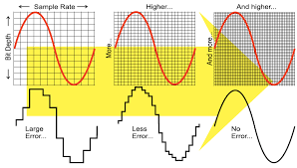

What will be the recording specs?

What are the target/final specs for the project?

What codec will you use?

Will you expect editorial (picture) to use same specs?

***Recordings***

Once production is complete you have a bunch of recordings. These recordings can be:

* Dialog recorded during a take
* Wild sounds – taken without images
* Outtakes
* Ambient sounds, room tone, etc.

**Additional Recordings after or during Principal Photography**

* ADR (Automated Dialogue Replacement_
* Foley (Sound FX matching)
* Sound FX
* Ambience

***Syncing***

Syncing means aligning. The lips must be in sync with the voice, and so on.

The traditional way to ensure syncing is by using a slate or clapboard. The modern way is by using Time Code, and/or an electronic slate as well. On low-budget productions, you usually record audio in sync with camera – sometimes with frustrating results.

Syncing sounds tedious, and it is. That’s why it is so important to get your workflow right on set.

This is done be assistant editors (picture editors).

This process is also called conforming, where you try to match audio and visuals. Conforming can also include dealing with codecs, changing duration, etc. In the olden days you just aligned them.

Syncing Dailies (a term from the film days), is an activity that you do (which is why it is in blue); to bring all the unruly recordings under their respective visuals. Without this step the editing process cannot begin.

***Media Management/Work Flow***

* + Work Flow Charts/Diagrams
  + Cue Sheets
  + Specification Sheets for media
  + Naming Conventions for files, drives, directories, hand off folders, etc.
  + Notes from editorial, director, set sound, etc.

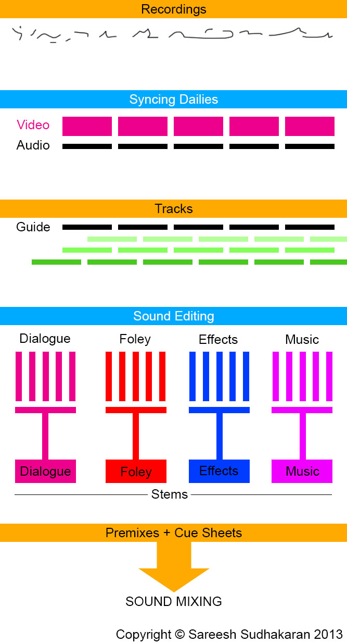

***Editing (Picture and Sound)***

Due to the nature of editing, and the nature of human beings in general, it is almost impossible to know when exactly an edit will be ‘locked’, i.e., finished for good. Sometimes it is locked many times, sometimes only once. Usually it’s in between these two extremes.

Therefore, on complicated projects like feature films, etc., sound editing also involves the Editor and the Assistant Editor (picture editors). Nobody wants to go back to redo things, so it is better to let them sit together and share the pain. It might not seem like the right way, but creativity is rarely linear, so a circular workflow is a necessary evil.

What essentially happens is, the ‘correct’ or ‘preferred’ sounds are placed on the timeline, in tracks. This happens in the NLE first, and then in the DAW (Digital Audio Workstation – the audio equivalent of the NLE). This is what it looks like in the DAW:

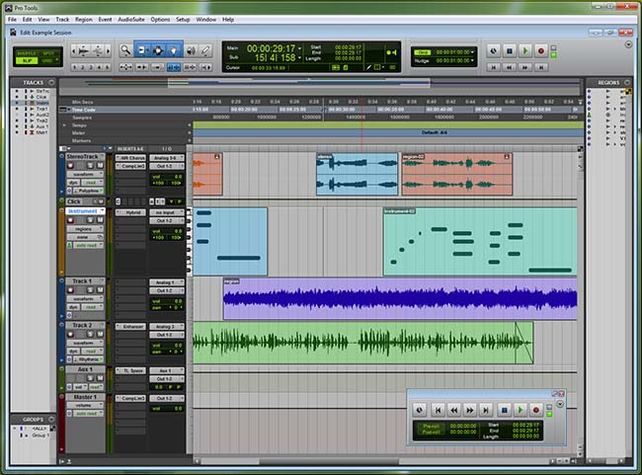

**Will you inform the editorial staff and provide them with audio files?**

Each row is a track. The system is similar for NLEs and DAWs. It is the job of the editors, both video and sound, to organize the recordings into readily available tracks. On a feature film, these tracks can run into the hundreds, so you can appreciate the importance of proper organization.

All tracks are correctly named so that the sound editing team can understand the editor’s and filmmaker’s intentions. Once the edit is locked, the ‘finished’ audio timeline becomes a guide track. The guide track preserves the filmmakers’ intentions, and it forms the basis for the sound editor to do his or her magic. It is also important in the sense that you don’t miss anything. It is easy to miss a small effect or audio sample in the large expanse that is the DAW’s timeline.

***Sound Editing***

The sound editor assembles and organizes the audio recordings and tracks, not in the way the editor did it, but in the way that is most beneficial for the rest of the audio workflow.

If you study the chart closely, you’ll see the sound editing phase divides audio samples (recordings, tracks) into three major categories:

Dialogue

Music and

Effects (SDFX, Foley and ATMOS)

Dialogue can come from recordings on set, Wild recordings, ADR, and so on. All of these sounds are:

* Chosen – find the best possible recordings for the final mix.
* Cleaned – for noise, artifacts, reverb, etc.
* Filtered – various effects added to enhance or manipulate the recording to deliver a specific feel.
* Layered on the timeline, in sync with the visuals.

This is the stage where the sound editor also decides if any audio needs to be re-recorded. This is the stage where every sound is decided on, assembled and made ready for the final mix.

My explanation is slightly simplistic. The job is a major one. Some projects have multiple dialogue tracks (one in each language for foreign release), multiple song and music tracks (same reason), etc. All in all, you’re looking at hundreds of tracks, with no room for error. It is for this reason that there’s a separate Oscar category for Sound Editors – the job is as creatively and technically demanding as that of editors.

***Premixing***

Once all the different ‘groups’ of audio are ready to be passed on to the mixers, they are premixed. Dialogue is premixed, foley is premixed, music is premixed and other effects are premixed. The premix preserves the intentions of the filmmakers, and also creates what are known as Stems. You have a dialogue stem, foley stem, music stem and effects stem. You might also have several dialogue stems (one for each language) and so on.

Why premix? The guiding principle behind this is to ensure the sounds have been correctly positioned and treated, and are ready for the final mix. It also allows for an additional layer of ‘grouping’ (organizing data). We started with recordings, then synced them with video, then assembled them into tracks, then chose the best ones and edited them, and finally we group them into different branches or categories so they can be found easily.

The premixes, which might include the tracks unmixed as well (in case someone feels like changing anything), is sent to the sound mixers, along with the Cue Sheet. The cue sheet is just a document that explains, in timeline form, where each sound is located (written in time notation) and what effect or manipulation has been applied to it. This document preserves the intentions of the filmmakers, the editor, and the sound editor.

As you can see, we’re playing a complicated version of Chinese whispers here. Preserving the artistic intention while maintaining the most efficient workflow is the order of the day.

***Mixing (i.e. Re-Recording)***

Mixing is the art of:

* “Balancing” program materials Adjusting levels (volume), eq, compression etc. in different tracks so they play well together.
* Listening to mix through calibrated monitors in a controlled space.
* Listening to mix through various uncalibrated references
* Adhering to standardized playback levels (79dbSPL, 83, 85)
* Adhering to standardized technical specs.
* Adding, manipulating or removing certain effects and filters to change the quality of the sound.
* Preparing a final master from which other soundtracks can be derived.

In essence, mixing is the mixing of tracks to make them play well together, while preserving the artistic intent of the filmmaker and the story. Other than this, anything goes.

As far as filmmaking is concerned, the process is also called **Re-recording.**

The captain of the ship is the Lead Mixer, sometimes called the re-recording mixer.

**What do you do in a Mix?**

There are infinite tools available at a mixer’s disposal, only limited by budget. On average, the better a tool is, the more it costs. One must also factor in warranty and service. You can’t halt a mixing session for want of one potentiometer (pot).

Consider the following list a basic primer only. Here are some important functions of a mixing tool(s):

* Levels – adjusting the volume
* Muting single tracks or stems – ability to listen to only certain sections at a time
* Limiting – the power to set upper and lower limits to levels
* Compression – the ability to compress audio levels into a smaller region (reducing its dynamic range) to save space
* Expansion – the ability to increase the dynamic range, levels-wise, if you want to go that route
* Equalization – playing with the frequencies or bands of frequencies (like bass, treble, etc.)
* Filtering – taking out parts (frequencies) of sounds by passing them through filters
* Reverberation – adding reverb or echo to match sounds or generate an effect
* Pitch – change pitch
* Synthesis – generate sounds to use quickly – you can’t always go back to sound editing, so some overlapping is designed into the process
* Panning – Controlling space to make sound come alive within several channels (like stereo, surround, etc.)
* These tools are not used in the order I have written them in. Sound mixers work in reels or sequences, but the workflow is always circular. The filmmakers might always change their minds, and the mixers are trained to accept these changes. That’s why they charge by the hour!

All said and done, sound mixing is a creative pursuit. Most filmmakers cannot sit through a mixing session without losing their ability to judge. Imagine the skill a sound mixer must have, then!

What do you get at the end? You get the final mix, also called a master. But, how many masters are there?

**The Master Mix**

If you glance through the available digital audio standards for theatrical distribution, you might come across the following names:

* THX – controlled environment standard – you mix in THX-certified environment and playback in one – there is no licensing involved.
* Dolby Digital – a 6-channel encoding format – you must buy a license to use this format.
* DTS – a 6-channel encoding format – you must buy a license to use this format.
* SDDS – an 8-channel encoding format – you must buy a license to use this format.

And many others. What do they mean?

These are standards that attempt to keep the audio sound acceptably the same, as long as you use their equipment. In effect, what they are doing is forcing you to pay for equipment that only supports their standard, which then restricts your audio to their standard, so your audio can only play back properly in their equipment! Do you feel like you’ve been hit by a truck? You’re not alone. To be fair to them, though, this is a necessary evil. Otherwise, your audio will sound differently in every venue. What’s the point of preserving your artistic intention so carefully, if nobody else is going to hear it?

Also, these guys have pretty good ‘standards’, and they are industry leaders in the field of theatrical audio. The problem though, is in choosing which one is right for your project. You don’t know this until you have your distribution deals in place. Otherwise, you are just shooting in the dark. A final mix keeps music and effects (M&E) separate, so that foreign language dialogues can be dubbed (another stem) instead. All tracks, stems and project files are preserved for posterity.

From the master one proceeds to produce other mixes, like the DVD or Blu-ray mix, television stereo and 5.1 mix, etc. Unlike video transcoding, mixing must be done from scratch – it’s not an automated process. It is for this reason that film audio budgets are large, and those who don’t consider them in advance find themselves scratching their heads later. If your intention is a theatrical release, you must factor in all these mixes as part of your budget. Some distributors don’t accept movies without M&E done separately.

I hope this brief overview has given you enough information to get started on planning your own post production audio workflow. The road to a great soundtrack isn’t an easy or linear one. Still, it needs adequate attention, and great skill from those who work on it.

Don’t ever underestimate audio.

**Examples**

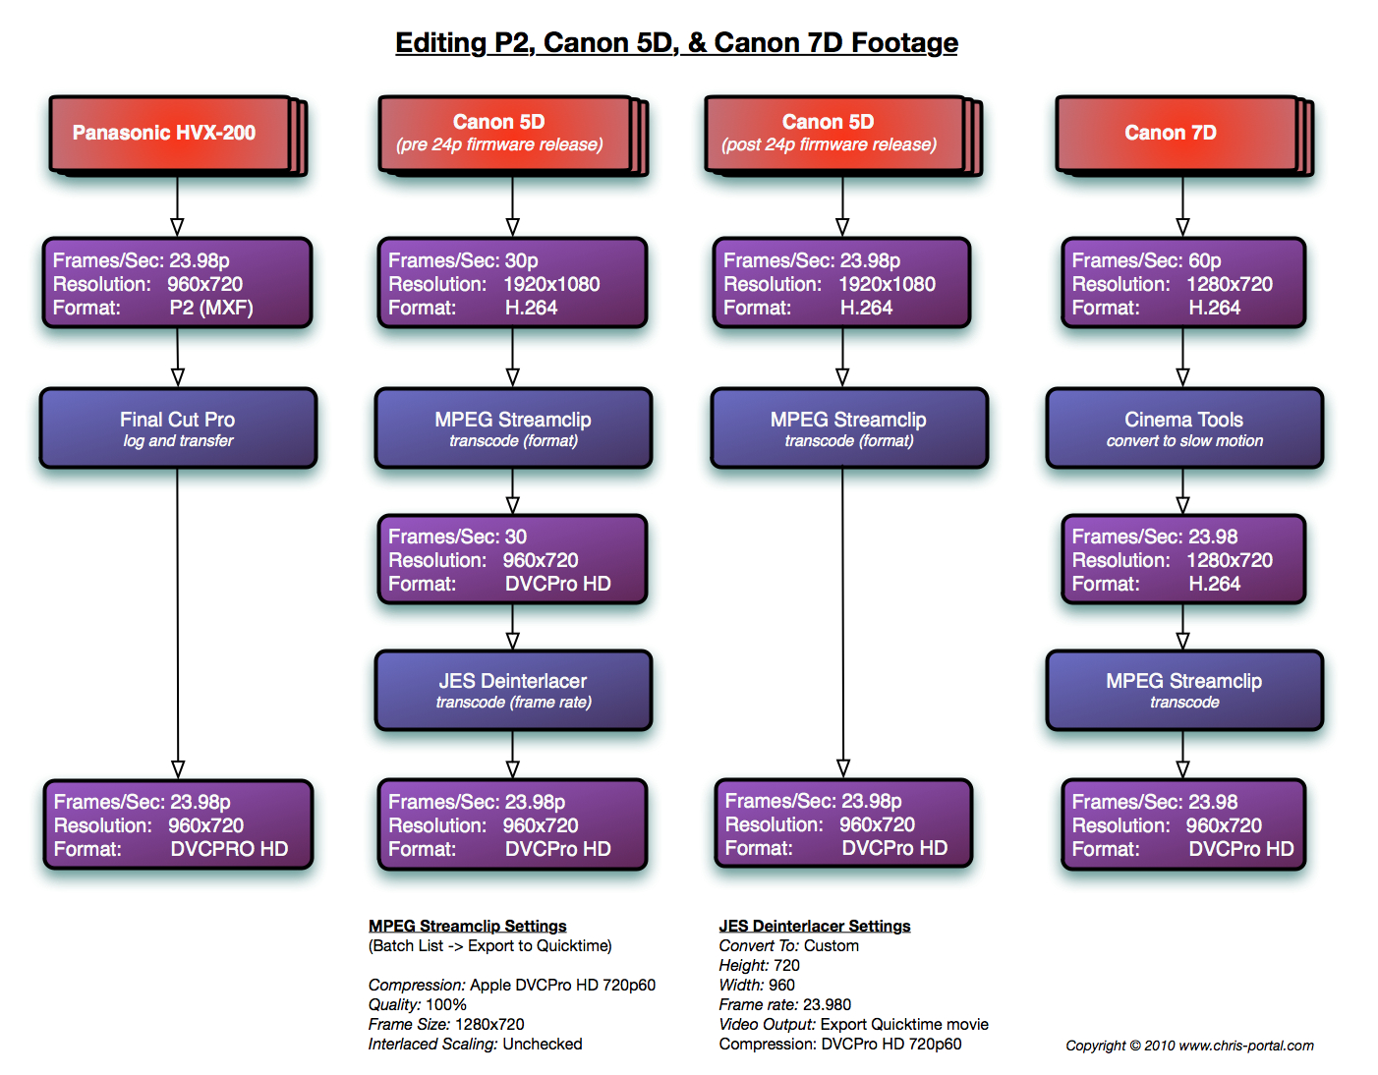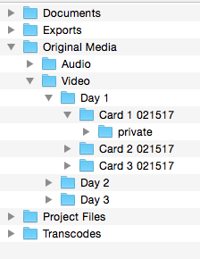 **Naming Conventions/Structure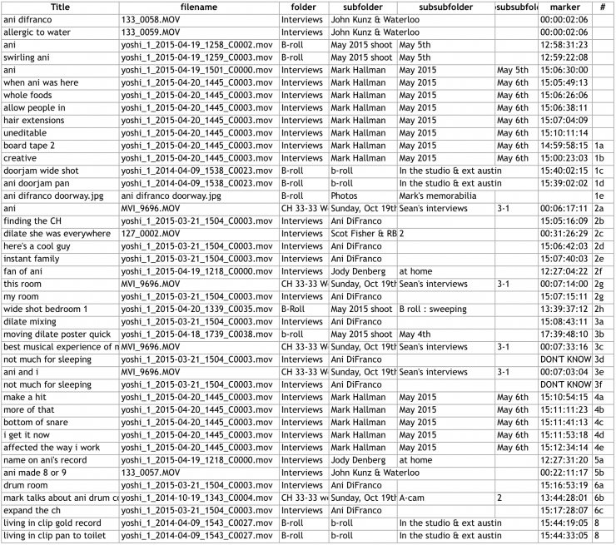Notes/Cue Sheets etc.**

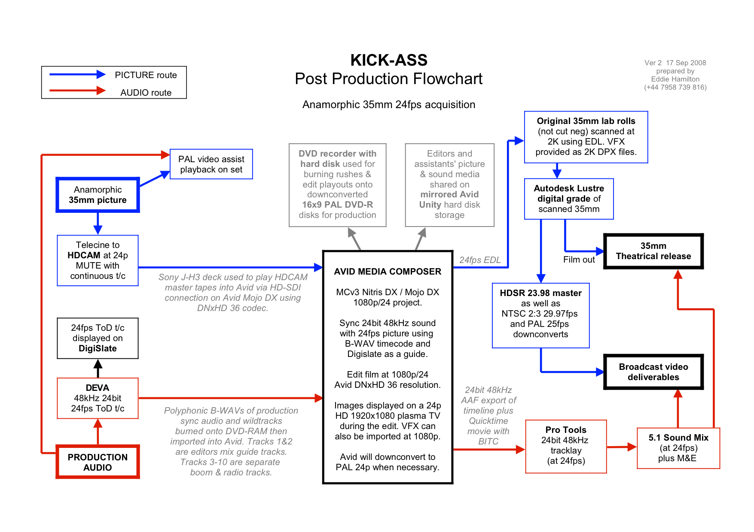

**Schedules**