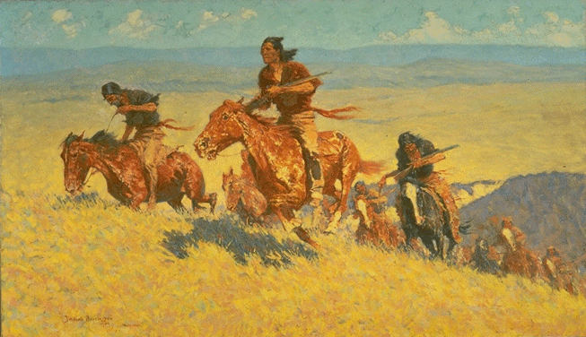
BUFFALO RUNNERS - BIG HORN BASIN
by Frederic Remington
1909 Oil on canvas 30-1/8" x 51-1/8"

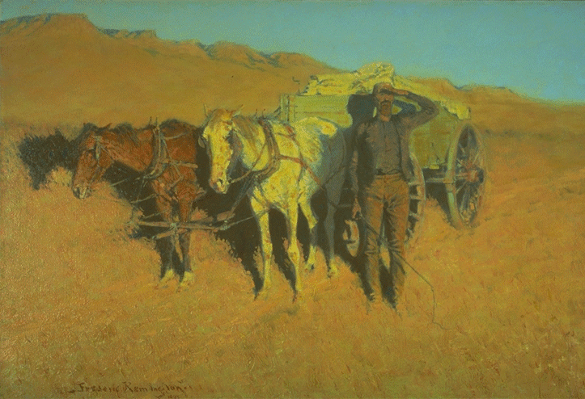
THE DRY CAMP
by Frederic Remington
1907 Oil on Canvas 27-3/8" x 40"

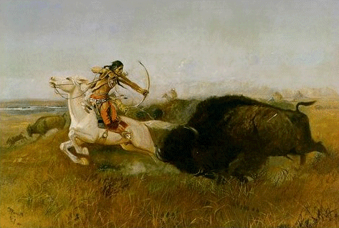
INDIANS HUNTING BUFFALO [Wild Men's Meat; Buffalo Hunt]
by Charles M. Russell
1894 Oil on canvas 24-1/8" x 36-1/8"

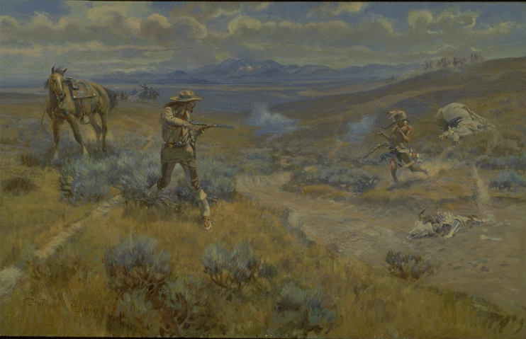
BUFFALO BILL'S DUEL WITH YELLOWHAND
by Charles M. Russell
1917 Oil on canvas 29-7/8" X 47-7/8"

