Roundhay Garden Scene
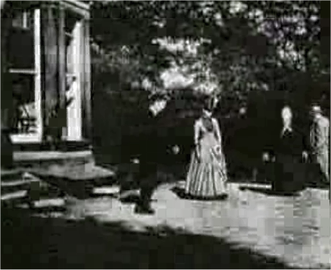
Directed by Louis Le Prince (French)
Produced by Louis Le Prince
Starring Adolphe Le Prince (son)
Sarah Whitley (mother-in-law)
Joseph Whitley (father-in-law)
Harriet Hartley
Music byNone
Cinematography Louis Le Prince
Editing by Louis Le Prince
Distributed by Louis Le Prince
Release date(s) Oct. 14, 1888
Running time +2.11 secs (NMPFT) (24.64fps)
+1.66 secs (NSM) (12fps)
Country England
Language Silent
Preceded by Unknown
Followed by Leeds Bridge

Roundhay Garden Scene is an 1888 short film directed by French inventor Louis Le Prince. It was recorded at 12 frames per second and is the earliest surviving film.[1]
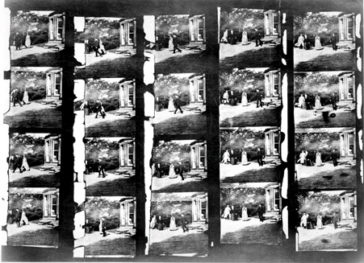
Overview

According to Le Prince's son, Adolphe, it was filmed at Oakwood Grange, the home of Joseph and Sarah Whitley, in Roundhay, Leeds, West Yorkshire, England on October 14, 1888.
It features Adolphe Le Prince, Sarah Whitley, Joseph Whitley and Harriet Hartley in the garden, walking around and laughing. Note that Sarah is walking backwards and that Joseph's coat tails are flying.
Remastered footage

1930 NSM copy of 20 frames from the Roundhay Garden Scene
In 1930 the National Science Museum (NSM), London, produced photographic copies of remaining parts from the 1888 filmstrip. This sequence was recorded on an 1885 Eastman Kodak paper base photographic film through Le Prince's single-lens combi camera-projector. Le Prince's son, Adolphe, stated that the Roundhay Garden was shot at 12 fps (and the second movie, Leeds Bridge, at 20 fps), however the later digital remastered version of Roundhay Garden produced by the National Museum of Photography, Film and Television (NMPFT), Bradford, uses 52 frames and is only 2.11 seconds long, as the film runs at 24.64fps, the modern cinematographic frame-rate. The National Science Museum copy has 20 frames, giving a run time of 1.66 seconds at 12fps.

[edit]Aftermath

This historical film is surrounded with tragedy and mystery. On October 24, 1888, only ten days after being filmed in Roundhay Garden Scene, Sarah Robinson Whitley, featured actress, and Le Prince's mother-in-law, died aged 72 and was buried nearby on October 27 at St. John's Church, Roundhay, Leeds. On September 16, 1890, while about to patent his invention in London and to perform his first official public exhibition in New York, Louis Le Prince, director, mysteriously vanished in a train between Dijon and Paris. In 1902, two years after testifying in the Equity 6928 brief, Alphonse Le Prince, featured actor and elder son of the inventor, was found shot dead in New York.

