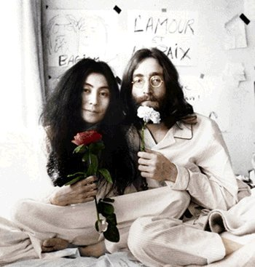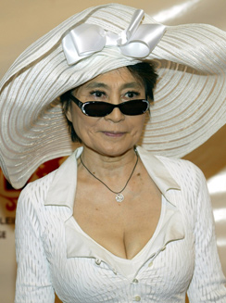
"The world's most famous unknown artist: everybody knows her name, but nobody knows what she does." –John Lennon
Yoko Ono born on February 18, 1933 and is still alive today. Ono is a Japanese artist and musician. She is known for her work as avant-garde artist and musician and her marriage and works with English musician John Lennon.
Ono left Japan and moved to New York after the war, and enrolled in nearby Sarah Lawrence College. While her parents approved of her college choice, they were dismayed at her lifestyle, and, according to Ono, chastised her for befriending people they considered to be "beneath" her. In spite of this, Ono loved meeting artists, poets and others who represented the "Bohemian" freedom she longed for herself. Visiting galleries and art "happenings" in the city whetted her desire to publicly display her own artistic endeavors. La Monte Young, her first important contact in the New York art world, helped Ono start her career by using her Lower East Side loft as a concert hall..
In 1956, she married composer Toshi Ichiyanagi. They divorced in 1962 after living apart for several years. On November 28 that same year, Ono married American Anthony Cox. Cox was a jazz musician, film producer and art promoter. He had heard of Ono in New York and tracked her down to a mental institution in Japan, where her family had placed her following a suicide attempt.
Their marriage was annulled on March 1, 1963 (Ono having neglected to finalize her divorce from Ichiyanagi first); they re-married on June 6, and finally divorced on February 2, 1969. Their daughter, Kyoko Chan Cox, was born on August 8, 1963. The marriage quickly fell apart (as observers describe Tony and Ono threatening each other with kitchen knives) but the Coxes stayed together for the sake of their joint career. They performed at Tokyo's Sogetsu Hall with Ono lying atop a piano played by John Cage. Soon the Coxes returned to New York with Kyoko.
In the early years of this marriage, Ono left most of Kyoko's parenting to Cox while she pursued her art full-time and Tony managed publicity. After she left Cox for John Lennon, Ono and Cox engaged in a bitter legal battle for custody of Kyoko, which resulted in Ono being awarded full custody. However, in 1971, Cox disappeared with eight-year-old Kyoko, in violation of the custody order. Cox subsequently became a Christian and raised Kyoko in a Christian group known as the Church of the Living Word (or "the Walk"). Cox left the group with Kyoko in 1977. Living an underground existence, Cox changed the girl's name to Rosemary. In 1980, Cox and Kyoko sent a sympathy message to Ono after the death of John Lennon. Afterward, the bitterness between the parents lessened slightly and Ono publicly announced in People Magazine that she would no longer seek out the now-adult Kyoko but still wished to make contact with her. Ono and Kyoko were finally reunited in 1994.
Some critics have described Ono's art as a synthesis between John Cage's Zen-influenced musical ideas, incorporating silence and natural sounds, and Maciunas' earthier and more macabre wit, which found an echo in Ono's readiness to shock and dramatizations of her mental pain as well as her shared appreciation of gags (she once said, "Every artist is a conceptual artist. I'm a con artist"). Another influence was Ono's Japanese contemporary Yayoi Kusama. Kusama's events involving nudity may have inspired the famous cover of Ono and John Lennon's Two Virgins record, where both appear nude. Kusama was also an organizer of pacifist events similar to Ono and Lennon's "bed-in" interviews.
Ono was an explorer of conceptual art and performance art. An example of her performance art is "Cut Piece", 1964 as a protest for peace, during which she sat on stage and invited the audience to use scissors to cut off her clothing until she was naked. Ono performed this piece in Tokyo as well as London, garnering drastically different attention. Ono's cultural background and reality as a woman, placed her as submissive, and fully covered. Cutting the clothing away would be an act that destroyed the social protections and in a way, be a rape. An example of her conceptual art includes her book of instructions called Grapefruit. This book, first produced in 1964, includes surreal, Zen-like instructions that are to be completed in the mind of the reader.
Ono was also an experimental filmmaker who made sixteen films between 1964 and 1972, and gained particular renown for a 1966 film called simply No. 4, but often referred to as "Bottoms". The film consists of a series of close-ups of human buttocks as the subject walks on a treadmill.
Ono received an honorary Doctorate of Laws from Liverpool University in 2001; in 2002 she was presented with the honorary degree of Doctor of Fine Arts from Bard College. Scott MacDonald, visiting professor of film at Bard, said: "She is to be congratulated for the body of work she has made, and celebrated for what she has come to represent, within media history and throughout the world: courage, resilience, persistence, independence, and above all, imagination, and a belief that peace and love remain the way toward a brighter, ever-more-diverse human future."

