Naomi Uman
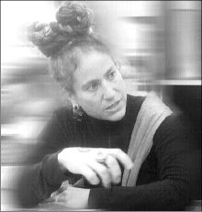

Former private chef to Malcolm Forbes, Calvin Klein and Gloria Vanderbilt, Naomi Uman recently traded in her eggbeater and oven mitts for a 16mm Bolex and acid resistant black rubber gloves. Naomi’s work is marked by her signature handmade aesthetic, often shooting, hand-processing and editing her films with the most rudimentary of practices. Naomi's films have been exhibited widely at the Sundance and Rotterdam International Film Festivals, The New York Film Festival, and the San Francisco International Film festival among others; she has also screened her work at The Guggenheim Museum, The Whitney, The Smithsonian, and Mexico City's Museo de Arte Moderno.
Naomi Uman is a hands-on filmmaker: for Leche (1998), a study of a Mexican dairy farm, the California artist processed 16-millimeter footage in a bathtub; for her coy Removed (1999) she bleached away the contours of a naked woman from the frames of a '70s porn film; and in Hand Eye Coordination (2002) she shows her own hands scratching the emulsion off the celluloid. Whether milking a cow, dialing a rotary phone, or masturbating, women's hands abound in these impish reveries, which are accompanied by nonsynchronous montages of found sound.
She currently resides in Mexico with her small dog, where she teaches workshops in handmade filmmaking at the Fine Art Museum in Mexico City.

