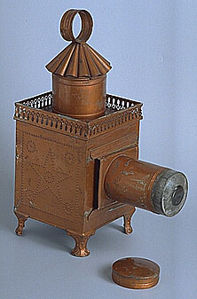
Magic lantern

Augustin Lapierre, Paris, 1860s
Size: 145mm x 250mm x 360mm
EXEBD 69000
This delicate embossed lantern could only have been used for small-scale projection: its thin metal walls and small body would allow a light source no stronger than its small oil lamp, and its lens would be unable to throw a picture more than a few metres. It is similar in size and shape to the lanterns shown in many 19th-century images of travelling lanternists, and was used as such in the Bill Douglas film Comrades in 1987. However this example was more likely to have been used as a parlour entertainment or children's toy. Lapierre was among the first of the large-scale commercial lantern manufacturers, producing cheap lanterns of stamped tin on an increasingly industrialised scale from 1843 into the twentieth century.
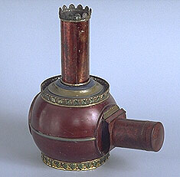

Magic lantern

Augustin Lapierre, Paris, late 19th century
Size: 225mm x 150mm x 260mm
EXEBD 69096
Its small size and decorative enamelled finish suggest that this lantern was for domestic rather than trade use: fragile elements like the chimney-top crown would have been little use to the travelling lanternist. The spherical body is relatively small: it could only have housed a relatively weak light source such as an oil lamp. This type of parlour lantern would have been used to show long 'panorama' slides, each showing a successive series of images, rather than the larger wooden-framed single-image slides more common in the trade. The slides would be passed though the slot between the body of the lantern and the lens tube and moved slightly to show the next image in sequence.

