
Alfred Hitchcock made a total of 37 self-referential cameos in his films over a 50 year period (from 1926-1976), if one counts his narration at the start of The Wrong Man (1956). Hitchcock's first appearance was in his third film, The Lodger (1926), and then in just six more of his British films. Two war-time shorts after 1940, Bon Voyage (1944) and Aventure Malgache (1944), did not contain cameos either. The most ingenious cameo appearances were in films with limited sets, as in Lifeboat (1944), Rope (1948), and Dial M for Murder (1954). One recurring theme was that Hitchcock carried a stringed instrument in some of the cameos. Note: Only once did he appear in an installment of his Alfred Hitchcock Presents (1955-1966) TV show - besides his personal introductions - in the episode titled Dip in the Pool, he showed up on the cover of a magazine.
- - - - - - - - - - - - - - - - - - - - - - - - - - - - - - - - - - - - - - - - - - - - - - - - - - - - - - -
THE LODGER: A Story of the London Fog (1926)
At a desk in a newsroom (3 min). Then as bystander watching arrest (92 min)
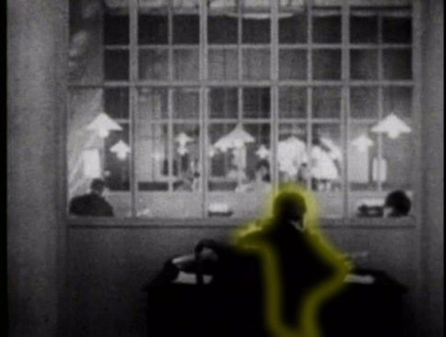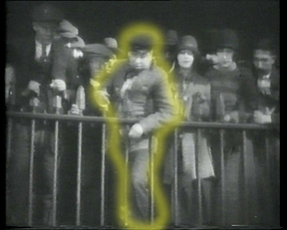
- - - - - - - - - - - - - - - - - - - - - - - - - - - - - - - - - - - - - - - - - - - - - - - - - - - - - - -
EASY VIRTUE (1927)
Walking past a tennis court, carrying a walking stick (15 min).
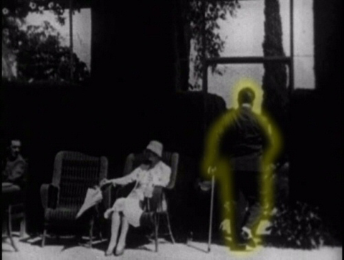
- - - - - - - - - - - - - - - - - - - - - - - - - - - - - - - - - - - - - - - - - - - - - - - - - - - - - - -
BLACKMAIL (1929)
Being bothered by a small boy as he reads a book in the subway. (11 min)
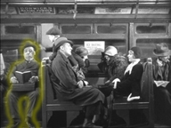
- - - - - - - - - - - - - - - - - - - - - - - - - - - - - - - - - - - - - - - - - - - - - - - - - - - - - - -
MURDER! (1930)
Walking past the house where the murder was committed, about an hour into the movie (60 min).
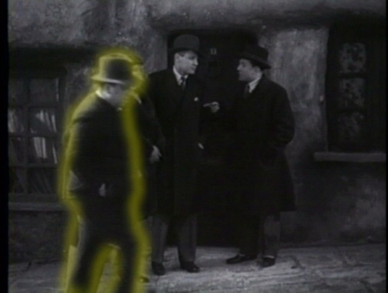
- - - - - - - - - - - - - - - - - - - - - - - - - - - - - - - - - - - - - - - - - - - - - - - - - - - - - - -
THE 39 STEPS (1935)
Tossing some litter while Robert Donat and Lucie Mannheim run from the theater (6 min).
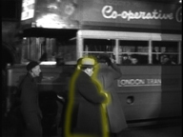
- - - - - - - - - - - - - - - - - - - - - - - - - - - - - - - - - - - - - - - - - - - - - - - - - - - - - - -
YOUNG AND INNOCENT (1938)
Outside the courthouse, holding a camera (15 min).
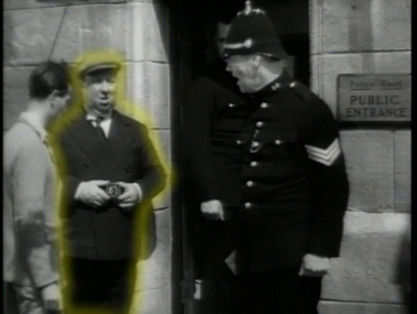
- - - - - - - - - - - - - - - - - - - - - - - - - - - - - - - - - - - - - - - - - - - - - - - - - - - - - - -
THE LADY VANISHES (1938)
Very near the end of the movie, in Victoria Station, wearing a black coat and smoking a cigarette (90 min).
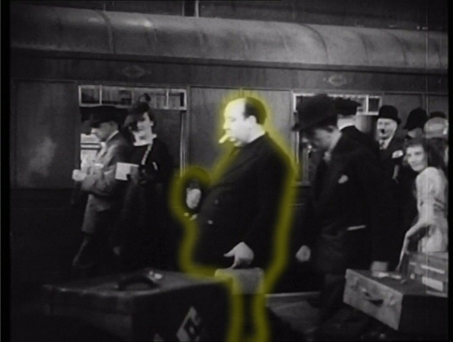
- - - - - - - - - - - - - - - - - - - - - - - - - - - - - - - - - - - - - - - - - - - - - - - - - - - - - - -
REBECCA (1940)
Walking near the phone booth in the final part of the film just after George Sanders makes a call (123 min).
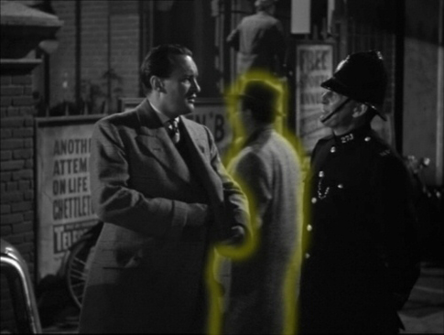
- - - - - - - - - - - - - - - - - - - - - - - - - - - - - - - - - - - - - - - - - - - - - - - - - - - - - - -
FOREIGN CORRESPONDENT (1940)
Early in the movie, after Joel McCrea leaves his hotel, wearing a coat and hat and reading a newspaper (11 min).
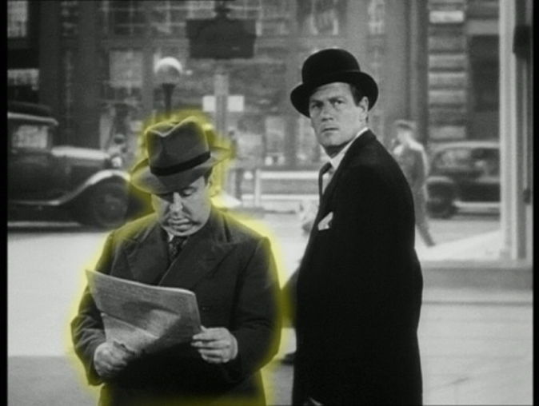
- - - - - - - - - - - - - - - - - - - - - - - - - - - - - - - - - - - - - - - - - - - - - - - - - - - - - - -
MR. AND MRS. SMITH (1941)
Midway through, passing Robert Montgomery in front of his building (41 min).
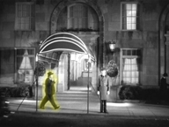
- - - - - - - - - - - - - - - - - - - - - - - - - - - - - - - - - - - - - - - - - - - - - - - - - - - - - - -
SUSPICION (1941)
Mailing a letter at the village postbox (45 min).
.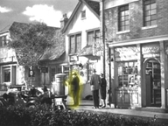
- - - - - - - - - - - - - - - - - - - - - - - - - - - - - - - - - - - - - - - - - - - - - - - - - - - - - - -
SABOTEUR (1942)
In front of Cut Rate Drugs in New York as the saboteur's car stops (60min).
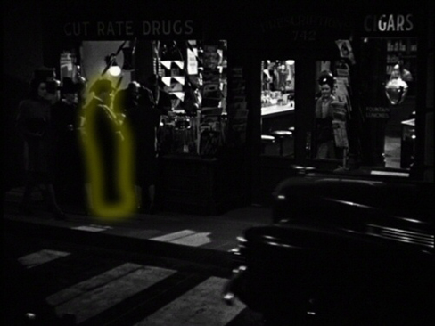
- - - - - - - - - - - - - - - - - - - - - - - - - - - - - - - - - - - - - - - - - - - - - - - - - - - - - - -
SHADOW OF A DOUBT (1943)
On the train to Santa Rosa, playing cards w/Full House of Spades (17 min).
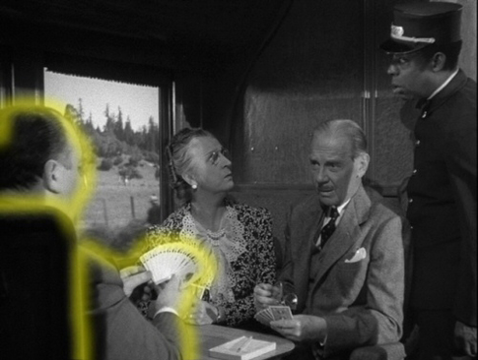
- - - - - - - - - - - - - - - - - - - - - - - - - - - - - - - - - - - - - - - - - - - - - - - - - - - - - - -
LIFEBOAT (1944)
In the "before" and "after" pictures in the newspaper ad for ”Reduco- Obesity Slayer” (25 min).
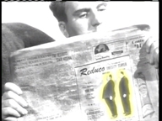
- - - - - - - - - - - - - - - - - - - - - - - - - - - - - - - - - - - - - - - - - - - - - - - - - - - - - - -
SPELLBOUND (1945)
Coming out of an elevator at the Empire Hotel, carrying a violin case and smoking a cigarette (36 min).
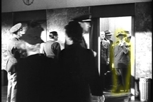
- - - - - - - - - - - - - - - - - - - - - - - - - - - - - - - - - - - - - - - - - - - - - - - - - - - - - - -
NOTORIOUS (1946)
At a big party in Claude Rains's mansion, drinking champagne and then quickly departing (64 min).
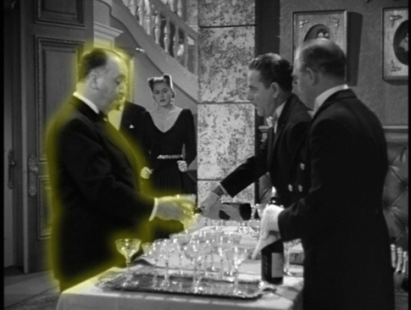
- - - - - - - - - - - - - - - - - - - - - - - - - - - - - - - - - - - - - - - - - - - - - - - - - - - - - - -
THE PARADINE CASE (1947)
Leaving the train and Cumberland Station, carrying a cello (36 min).
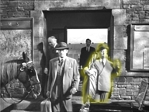
- - - - - - - - - - - - - - - - - - - - - - - - - - - - - - - - - - - - - - - - - - - - - - - - - - - - - - -
ROPE (1948)
Opening credits crossing street (1 min) His trademark can be seen briefly on a neon sign in the view from the apartment window (52 min).
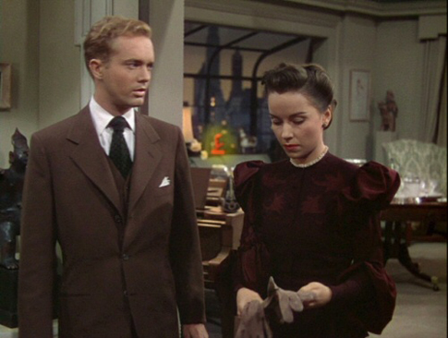
- - - - - - - - - - - - - - - - - - - - - - - - - - - - - - - - - - - - - - - - - - - - - - - - - - - - - - -
UNDER CAPRICORN (1949)
In the town square during a parade, wearing a blue coat and brown hat (3 min) Then he is one of three men on the steps of Government House (14 min).
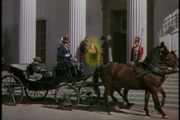
- - - - - - - - - - - - - - - - - - - - - - - - - - - - - - - - - - - - - - - - - - - - - - - - - - - - - - -
STAGE FRIGHT (1950)
Turning to look at Jane Wyman disguised as Marlene Dietrich's maid (38 min).
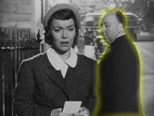
- - - - - - - - - - - - - - - - - - - - - - - - - - - - - - - - - - - - - - - - - - - - - - - - - - - - - - -
STRANGERS ON A TRAIN (1951)
Boarding a train with a double bass fiddle as Farley Granger gets off in his hometown, early in the film (10min).
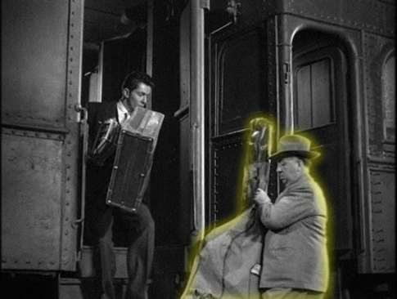
- - - - - - - - - - - - - - - - - - - - - - - - - - - - - - - - - - - - - - - - - - - - - - - - - - - - - - -
I CONFESS (1953)
Crossing the top of a staircase after the opening credits (1 min).
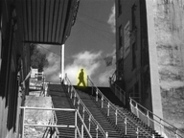
- - - - - - - - - - - - - - - - - - - - - - - - - - - - - - - - - - - - - - - - - - - - - - - - - - - - - - -
DIAL M FOR MURDER (1954)
On the left side of the class-reunion photo (13 min).
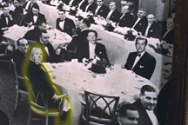
- - - - - - - - - - - - - - - - - - - - - - - - - - - - - - - - - - - - - - - - - - - - - - - - - - - - - - -
REAR WINDOW (1954)
Winding the clock in the songwriter's apartment (25 min).
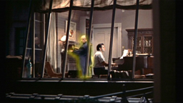
- - - - - - - - - - - - - - - - - - - - - - - - - - - - - - - - - - - - - - - - - - - - - - - - - - - - - - -
TO CATCH A THIEF (1955)
Ten minutes in, sitting to the left of Cary Grant on a bus (10 min).
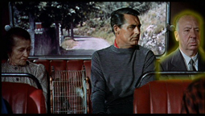
- - - - - - - - - - - - - - - - - - - - - - - - - - - - - - - - - - - - - - - - - - - - - - - - - - - - - - -
THE TROUBLE WITH HARRY (1955)
Walking past the parked limousine of an old man who is looking at paintings, twenty minutes into the film (21 min).
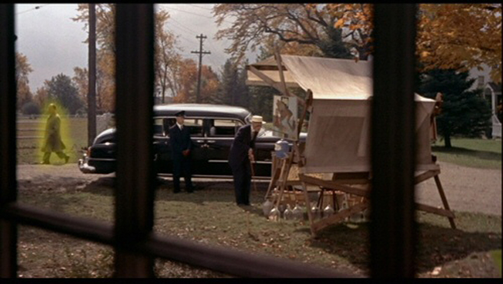
- - - - - - - - - - - - - - - - - - - - - - - - - - - - - - - - - - - - - - - - - - - - - - - - - - - - - - -
THE WRONG MAN (1956)
Narrating the film's prologue before the credits appear. Not a traditional cameo, but the sole time Hitchcock spoke in any of his feature films (Beginning).
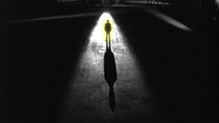
- - - - - - - - - - - - - - - - - - - - - - - - - - - - - - - - - - - - - - - - - - - - - - - - - - - - - - -
THE MAN WHO KNEW TOO MUCH (1956)
Watching acrobats in the Moroccan marketplace (his back to the camera) just before the murder (25 min).
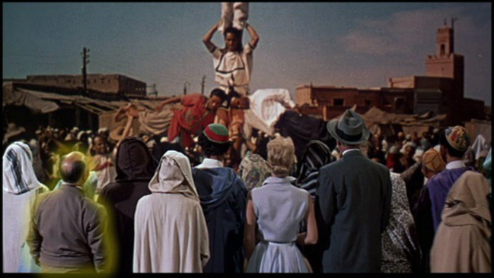
- - - - - - - - - - - - - - - - - - - - - - - - - - - - - - - - - - - - - - - - - - - - - - - - - - - - - - -
DIP IN THE POOL (from Alfred Hitchcock Presents-TV) (1957)
On the cover of a Magazine/Book (5 min).
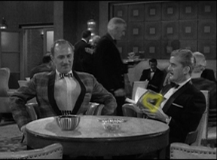
- - - - - - - - - - - - - - - - - - - - - - - - - - - - - - - - - - - - - - - - - - - - - - - - - - - - - - -
VERTIGO (1958)
In a gray suit walking in the street (11 min).
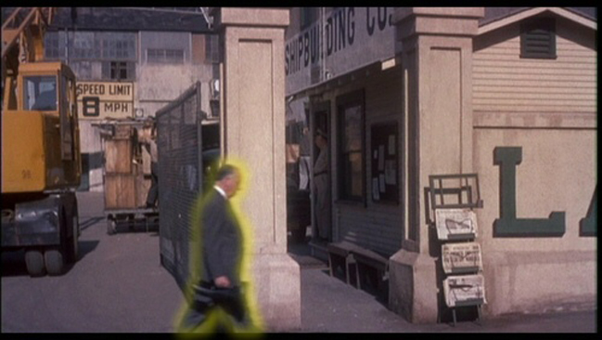
- - - - - - - - - - - - - - - - - - - - - - - - - - - - - - - - - - - - - - - - - - - - - - - - - - - - - - -
NORTH BY NORTHWEST (1959)
Missing a bus during the opening credits (2 min).
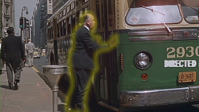
- - - - - - - - - - - - - - - - - - - - - - - - - - - - - - - - - - - - - - - - - - - - - - - - - - - - - - -
PSYCHO (1960)
Four minutes in, through Janet Leigh's window as she returns to her office. He is wearing a cowboy hat (7min).
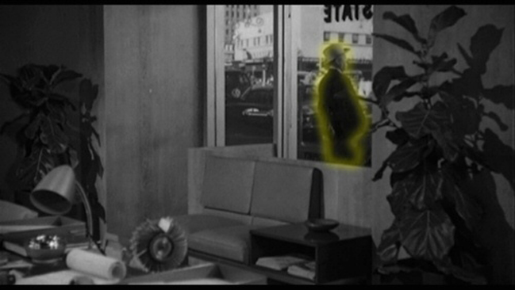
- - - - - - - - - - - - - - - - - - - - - - - - - - - - - - - - - - - - - - - - - - - - - - - - - - - - - - -
THE BIRDS (1963)
Leaving the pet shop with two white terriers as Tippi Hedren enters (2 min).
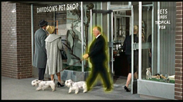
- - - - - - - - - - - - - - - - - - - - - - - - - - - - - - - - - - - - - - - - - - - - - - - - - - - - - - -
MARNIE (1964)
Entering from the left of the hotel corridor after Tippi Hedren passes by (5 min).
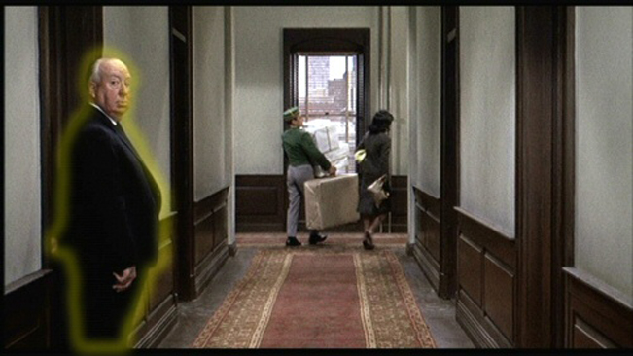
- - - - - - - - - - - - - - - - - - - - - - - - - - - - - - - - - - - - - - - - - - - - - - - - - - - - - - -
TORN CURTAIN (1966)
Early in the film, sitting in the Hotel d'Angleterre lobby with a blond baby (8 min).
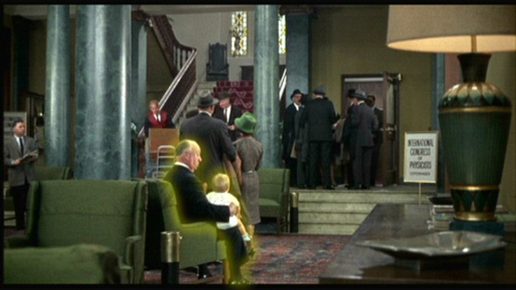
- - - - - - - - - - - - - - - - - - - - - - - - - - - - - - - - - - - - - - - - - - - - - - - - - - - - - - -
TOPAZ (1969)
Being pushed in a wheelchair in an airport, half an hour in. Hitchcock gets up from the chair, shakes hands with a man, and walks off to the right (28 min).
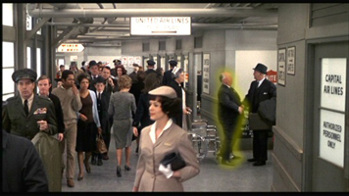
- - - - - - - - - - - - - - - - - - - - - - - - - - - - - - - - - - - - - - - - - - - - - - - - - - - - - - -
FRENZY (1972)
In the center of a crowd, wearing a bowler hat, three minutes into the film; he is the only one not applauding the speaker (3 min).
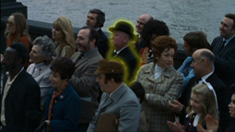
- - - - - - - - - - - - - - - - - - - - - - - - - - - - - - - - - - - - - - - - - - - - - - - - - - - - - - -
FAMILY PLOT (1976)
In silhouette through the door of the Registrar of Births and Deaths (41 min).


                                                      

