**Iconographic Elements and Motifs of the Western Genre**

**1.  SETTING**

1. **Modes of transportation:**
2. **The stagecoach/and or train itself as an emblem of progress, expansion.**
3. **The Horse as a symbol of freedom and individualism.**
4. **Nature: (i.e. The Plains, Mountains, Rivers) as symbols of freedom and escape (from past deeds? From people? From the law?) or as hardship, failure (man vs. nature). Vastness dwarfs heros and villians alike. Nature/Landscape become a third character.**
5. **Towns:  Civilization on the edge of failure/success. Towns as representations of the good in people or the bad in people. Civilization corrupt and attacked from within (corrupt lawmen/politician) or from outside (indians, cattle barons, the train company and its hired guns?)**

**d. Indians: The other, savages, attacking the town, farmer, family on the edge of the frontier. Or in revisionist Westerns, teacher/noble savages, spiritual guides to lost souls/wanderers/anti-heros**

**2.  THE FRONTIER as a meeting of old and new sets off a resulting series of oppositions/clashes in American Culture.**

**East                                        West**

**culture                                   nature**

**past                                        future**

**community                           individuality**

**law                                         pragmatis**

**refinement                        uncultured**

**safe dangerous**

**3. THE HERO/ANTI-HERO:  his/her individual violent acts validate the possibilities the frontier stands for, the restoration of order out of chaos.**

**a.       Mysterious, enters from the vast and unknowable landscape**

**b. Self Reliant/Loner (or at least a small select group of friends)**

**b.      Spiritual and/or vengeance aspect to the hero (sometime spiritual transformation as part of hero’s journey). He struggles with him/herself, with an injustice down by or to him/her.**

**c. Reluctantly and/or through a unique moral code the hero employs extreme violence to bring justice/order**

**d. Violence is employed quickly, without mercy (the individual as judge, jury and executioner, the individual as casual agent via swift violence). Unique in western narrative structure. Its equivalent is foundin the Japanese Samurai Film.**

**4. THE VILLIAN:  his/her role is unique malleable/flexible role in the Western Genre. Pitted again our Hero, the enemy/antagonist can almost anyone or anything. Again playing into the theme that the individual hero must rely only on him or herself to enact change.**

* 1. **Evil man in a black hat**
  2. **Cattle Baron driving farmers off their land**
  3. **Train company destroying a town for profit.**
  4. **Towns people abandoning their sheriff out of cowardice and fear.**
  5. **The Corrupt Sherriff.**
  6. **The Hired Guns of a Mining Company.**
  7. **Indian Tribes.**
  8. **Nature.**
  9. **Your own gang/treachery**

**The Phases of Genre**

*Genre Theory- Christian Metz's four stages of genre 'evolution.'*

*Christian Metz (1931-1993) was a French film theorist. He believed that genres go through a cycle of stages during their life time. These were:*

*Experimental stage*

*Classic stage*

*Parody stage*

*Deconstruction stage*

**THE WESTERN IS *THE* GREAT AMERICAN FORM** – The equivalent of Greek Tragedy or Japanese Kabuki

As Jazz is the only true original American form of Music the Western is the only truly unique cinema form.

Simple and elemental its often represents the schizophrenia and changing nature of the American Experience. Reflecting in clearer and broader tones the current state of American society and politics. Why? Because as a genre its more plastic, uniquely open/flexible in form because of where it stands in history.

Between myths/ficton and truth…westerns are a way to blend the two.

Only Genre named for its setting.

**Western Stars**

**William S. Hart**

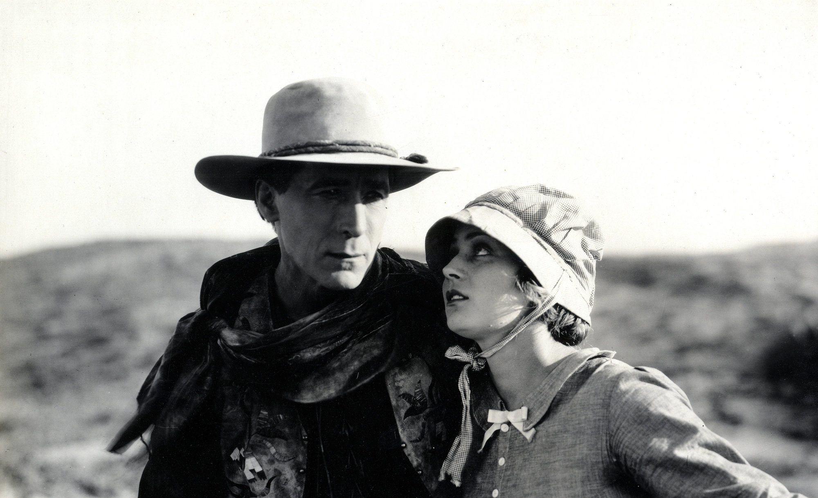

**John Wayne**

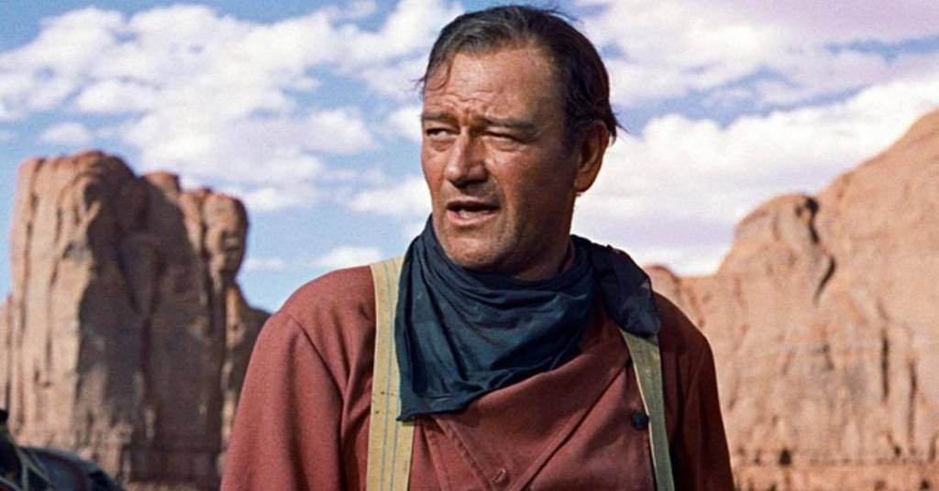

**Clint Eastwood**

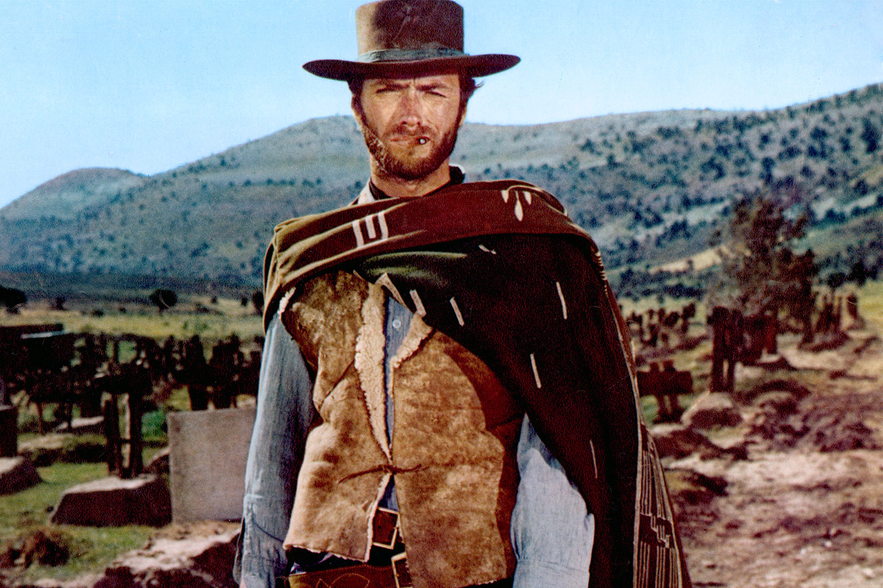

**WESTERN DIRECTORS**

**John Ford**

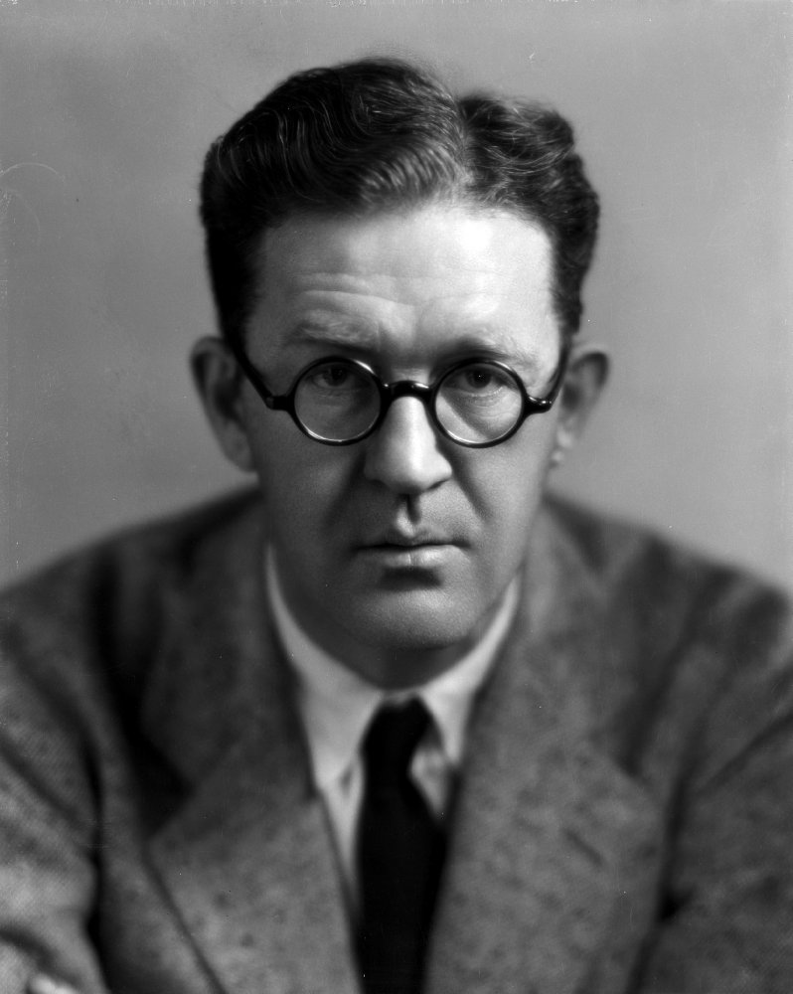

**Clint Eastwood**

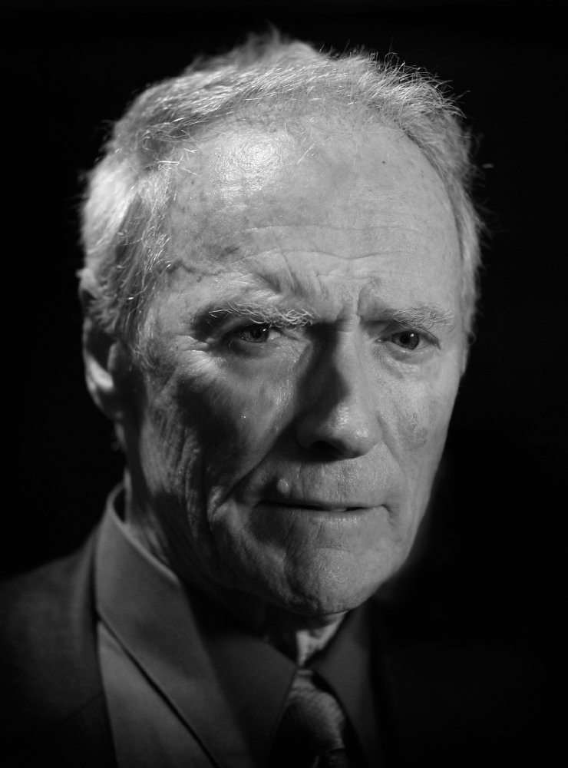

**Howard Hawks**

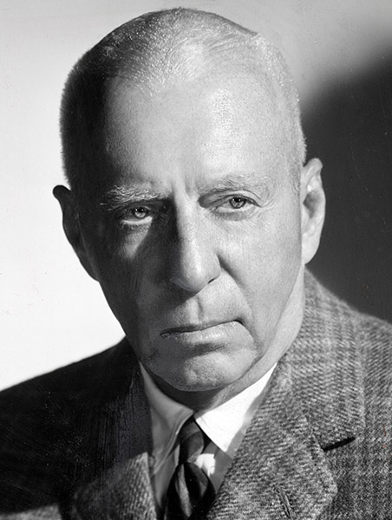

**Sergio Leone**

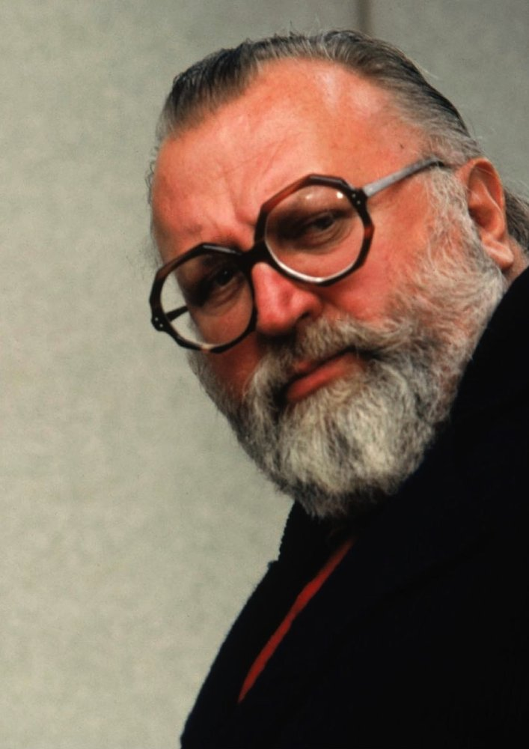

**Sam Peckinpah**

