**MAJOR FILM THEORISTS**

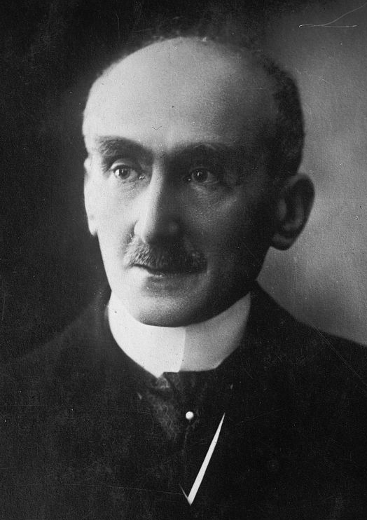**Henri-Louis Bergson** (French: [bɛʁksɔn]; 18 October 1859 – 4 January 1941) was a French philosopher, influential especially in the first half of the 20th century and after WWII in continental philosophy.

Bergson is known for his influential arguments that processes of immediate experience and intuition are more significant than abstract rationalism and science for understanding reality.

His book ***Matter and Memory (1896)*** has been cited as anticipating the development of film theory during the birth of cinema. Bergson commented on the need for new ways of thinking about movement, and coined the terms "the movement-image" and "the time-image". However, in his 1906 essay L'illusion cinématographique (in L'évolution créatrice; English: The cinematic illusion in Creative Evolution), he rejects film as an exemplification of what he had in mind.

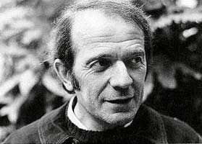**Gilles Deleuze**

Cinéma I and Cinema II (1983–1985), the philosopher Gilles Deleuze took Matter and Memory as the basis of his philosophy of film and revisited Bergson's concepts, combining them with the semiotics of Charles Sanders Peirce.

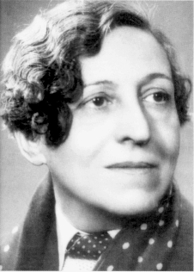**Germaine Dulac** (French: [dylak]; born Charlotte Elisabeth Germaine Saisset-Schneider; 17 November 1882 – 20 July 1942)[2] was a French filmmaker, film theorist, journalist and critic. She was born in Amiens and moved to Paris in early childhood. A few years after her marriage she embarked on a journalistic career in a feminist magazine, and later became interested in film. With the help of her husband and friend she founded a film company and directed a few commercial works before slowly moving into Impressionist and Surrealist territory. She is best known today for her Impressionist film, La Souriante Madame Beudet ("The Smiling Madam Beudet", 1922/23), and her Surrealist experiment, La Coquille et le Clergyman ("The Seashell and the Clergyman", 1928). Her career as filmmaker suffered after the introduction of sound film and she spent the last decade of her life working on newsreels for Pathé and Gaumont.

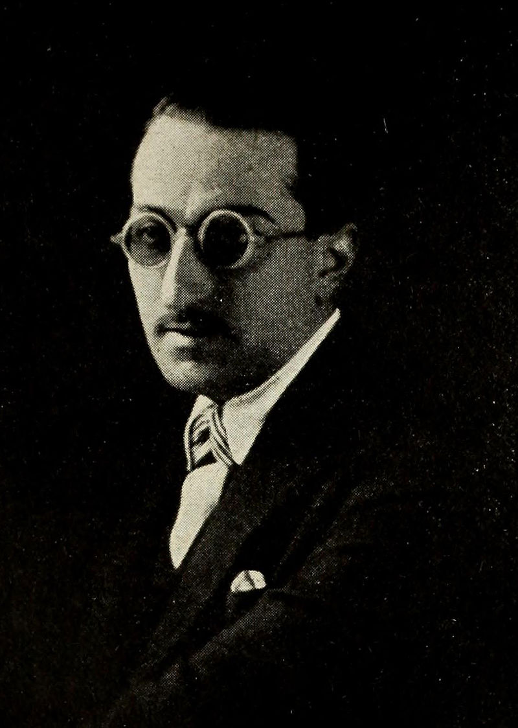**Louis Delluc** (French: [dɛlyk]; 14 October 1890 – 22 March 1924) was an Impressionist French film director, screen writer and film critic. Delluc was born in Cadouin in 1890. His family moved to Paris in 1903. After graduating from the university, he became a literary critic. During the First World War, he was married to the Belgian actress Ève Francis, who acted in many of his films.

In 1917, Delluc began his career in film criticism. He went on to edit Le Journal du Ciné-club and Cinéa, establish film societies, and direct seven films. He was one of the early Impressionist filmmakers, along with Abel Gance, Germaine Dulac, Marcel L'Herbier, and Jean Epstein. His films are notable for their focus on ordinary events and the natural setting rather than on adventures and antics. Many of his early film writings for French newspapers were collected in the volume Cinema et cie (1919). He also wrote one of the first books on Charlie Chaplin (1921; translated into English in 1922).

Delluc directed his seventh film, L'Inondation (The Flood), in 1924. Filming took place in very poor weather conditions and Delluc contracted pneumonia. He died in Paris several weeks later, before the film was released.

The Prix Louis-Delluc, created in 1937, is named in his honour.

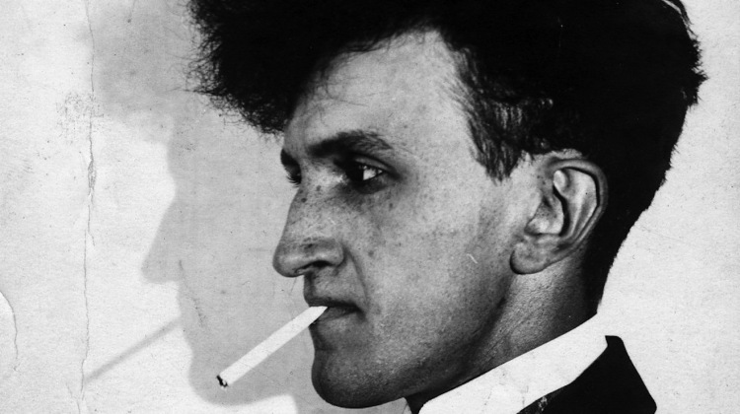**Jean Epstein** (French: [ɛp.ʃtajn]; March 25, 1897 – April 2, 1953) was a French filmmaker, film theorist, literary critic, and novelist. Although he is remembered today primarily for his adaptation of Edgar Allan Poe's "The Fall of the House of Usher", Epstein directed three dozen films and was an influential critic of literature and film from the early 1920s through the late 1940s. He is often associated with French Impressionist Cinema and the concept of photogénie.

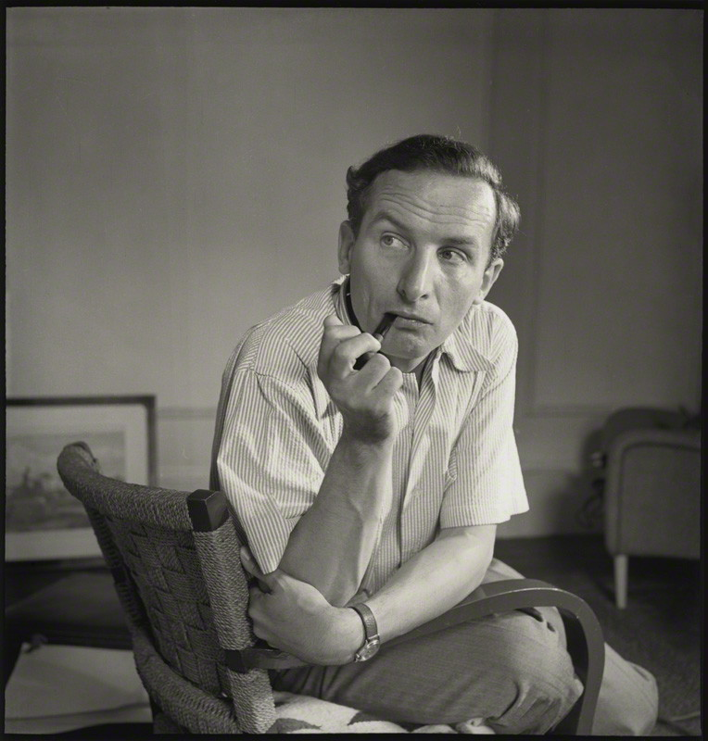

**Rudolf Arnheim** (July 15, 1904 – June 9, 2007) was a German-born author, art and film theorist, and perceptual psychologist. He learned Gestalt psychology from studying under Max Wertheimer and Wolfgang Köhler at the University of Berlin and applied it to art.[1] His magnum opus was his book Art and Visual Perception: A Psychology of the Creative Eye (1954). Other major books by Arnheim have included Visual Thinking (1969), and The Power of the Center: A Study of Composition in the Visual Arts (1982). Art and Visual Perception was revised, enlarged and published as a new version in 1974, and it has been translated into fourteen languages. He lived in Germany, Italy, England, and America. Most notably, Arnheim taught at Sarah Lawrence College, Harvard University, and the University of Michigan. He has greatly influenced art history and psychology in America.

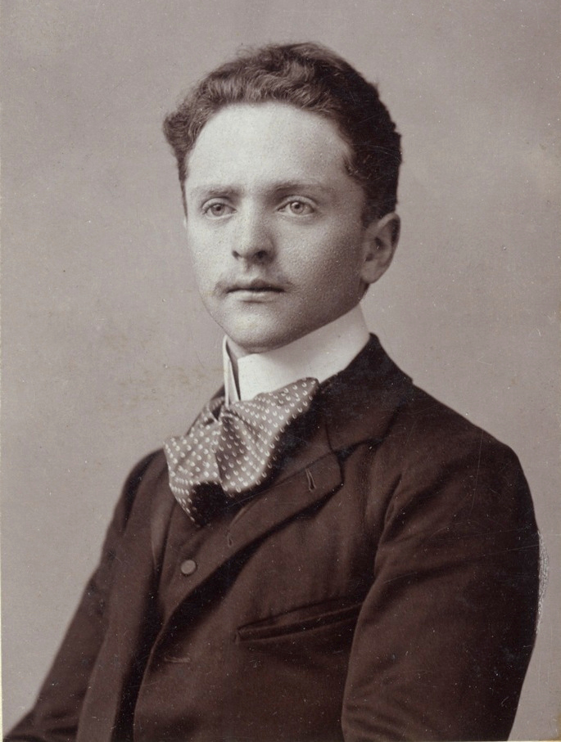**Béla Balázs** (Hungarian: [ˈbeːlɒ ˈbɒlaːʒ]; 4 August 1884, Szeged – 17 May 1949, Budapest), born Herbert Bauer, was a Hungarian-Jewish film critic, aesthete, writer and poet. In Vienna he became a prolific writer of film reviews. His first book on film, Der Sichtbare Mensch (The Visible Man) (1924), helped found the German "film as a language" theory, which also exerted an influence on Sergei Eisenstein and Vsevolod Pudovkin. A popular consultant, he wrote the screenplay for G. W. Pabst's film of Die Dreigroschenoper (1931), which became the object of a scandal and lawsuit by Brecht (who admitted to not reading the script) during production.

Later, he co-wrote (with Carl Mayer) and helped Leni Riefenstahl direct the film Das Blaue Licht (1932).[2] Riefenstahl later removed Balasz's and Mayer's names from the credits because they were Jewish.[3] One of his best known films is Somewhere in Europe (It Happened in Europe, 1947), directed by Géza von Radványi.

His last years were marked by petty vexations at home and ever increasing recognition in the German-speaking world. In 1949, he received the most distinguished prize in Hungary, the Kossuth Prize. Also in 1949, he finished Theory of the Film, published posthumously in English (London: Denis Dobson, 1952). In 1958, the Béla Balázs Prize was founded and named for him as an award to recognize achievements in cinematography.

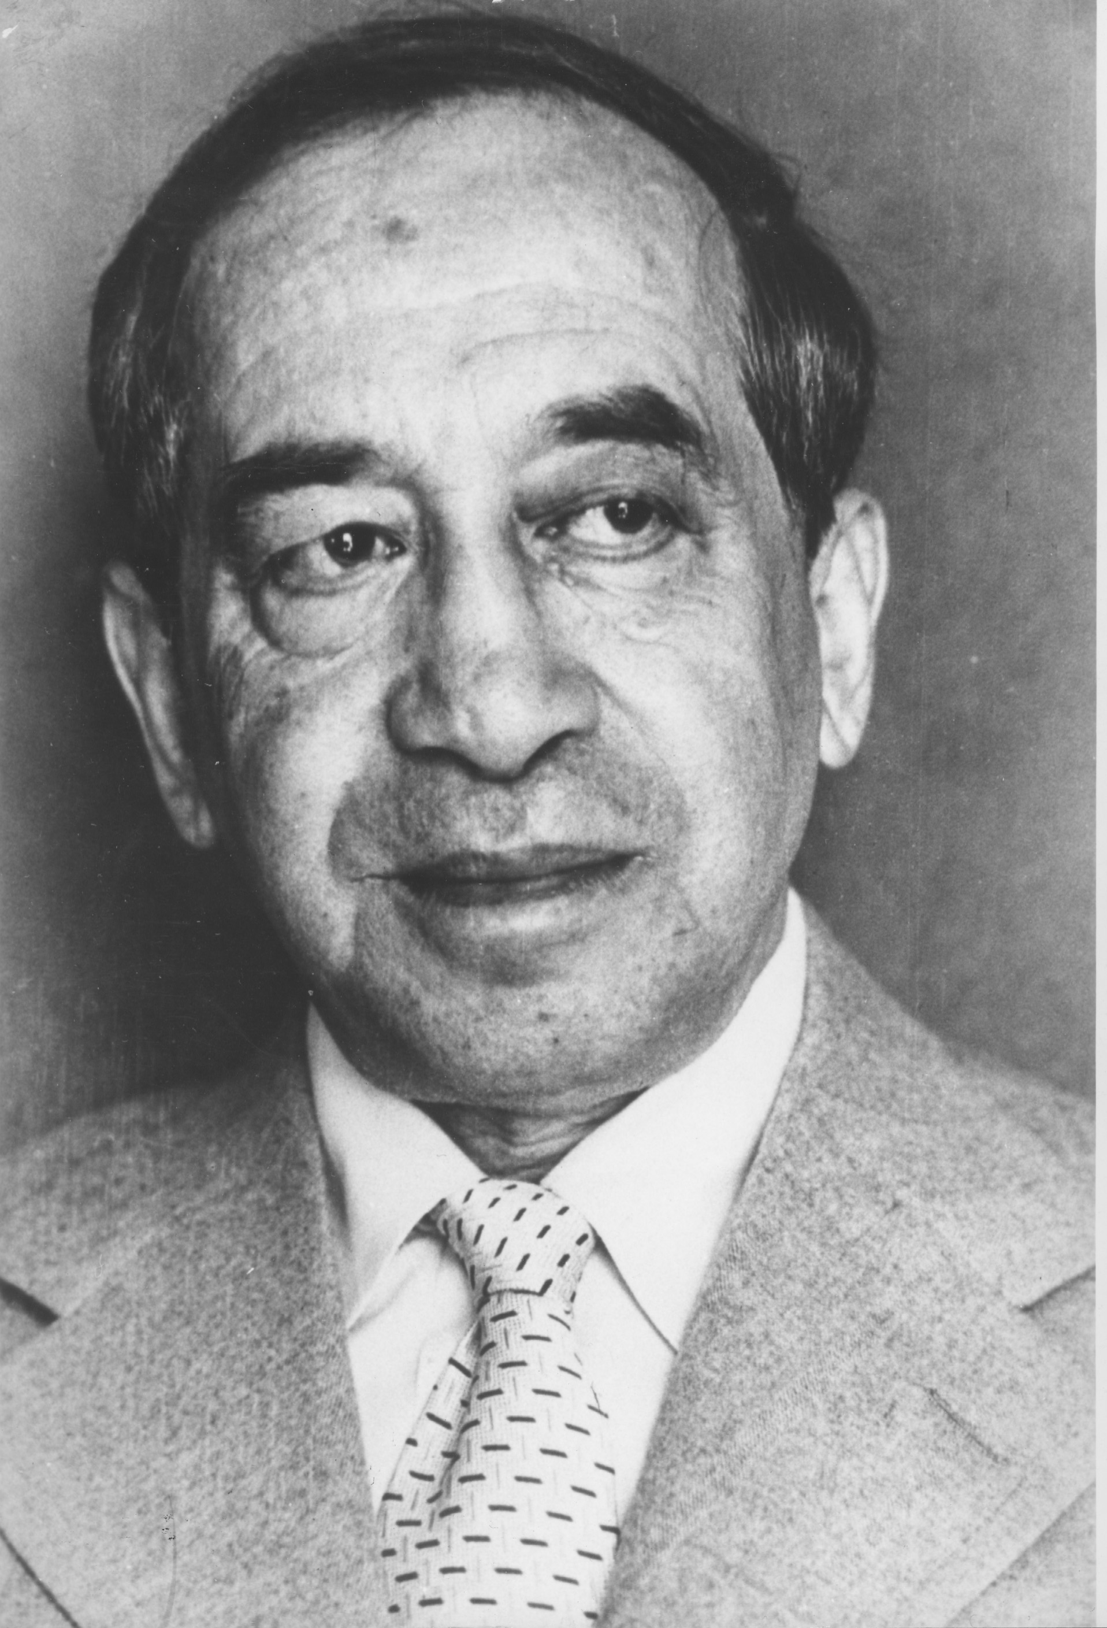**Siegfried Kracauer** (February 8, 1889 – November 26, 1966) was a German writer, journalist, sociologist, cultural critic, and film theorist. He has sometimes been associated with the Frankfurt School of critical theory.

From 1941 to 1943 he worked in the Museum of Modern Art in New York City, supported by Guggenheim and Rockefeller scholarships for his work in German film. Eventually, he published From Caligari to Hitler: A Psychological History of the German Film (1947), which traces the birth of Nazism from the cinema of the Weimar Republic as well as helping lay the foundation of modern film criticism.

In 1960, he released Theory of Film: The Redemption of Physical Reality, which argued that realism is the most important function of cinema.

**THE RUSSIANS**

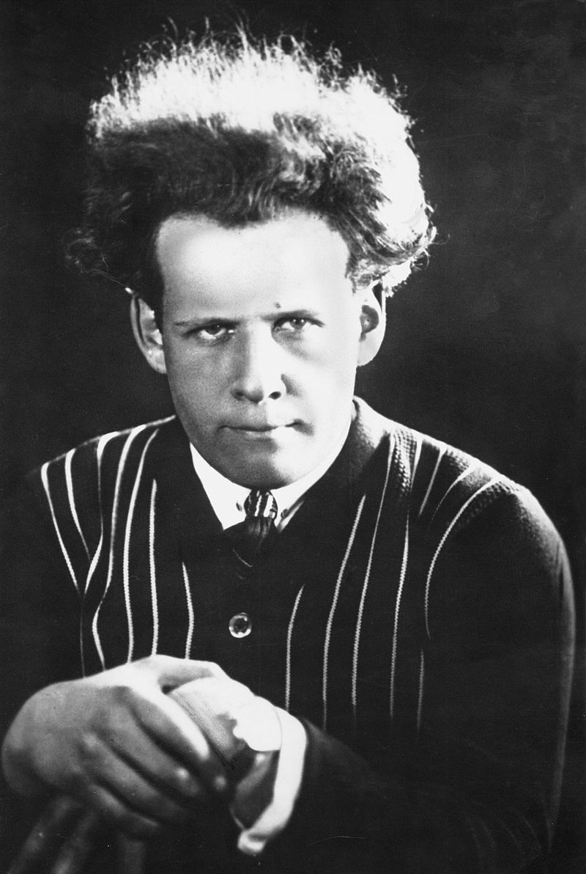

**Sergei Mikhailovich Eisenstein** (22 January [O.S. 10 January] 1898 – 11 February 1948) was a Soviet film director and film theorist, a pioneer in the theory and practice of montage. He is noted in particular for his silent films Strike (1925), Battleship Potemkin (1925) and October (1928), as well as the historical epics Alexander Nevsky (1938) and Ivan the Terrible (1944, 1958).

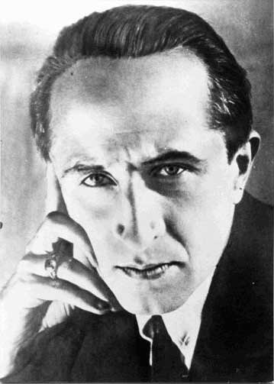**Lev Vladimirovich Kuleshov** (Russian: Лев Влади́мирович Кулешо́в; 13 January [O.S. 1 January] 1899 – 29 March 1970) was a Russian and Soviet filmmaker and film theorist, one of the founders of the world's first film school, the Moscow Film School. People's Artist of the RSFSR (1969).

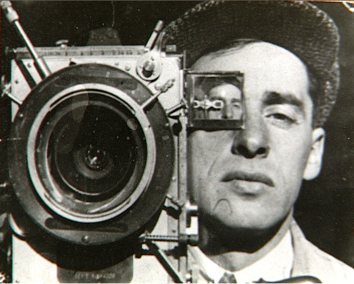**Dziga Vertov** (Russian: Дзига Вертов; born David Abelevich Kaufman, Russian: Дави́д А́белевич Ка́уфман, and also known as Denis Kaufman; 2 January 1896 – 12 February 1954) was a Soviet pioneer documentary film and newsreel director, as well as a cinema theorist. His filming practices and theories influenced the cinéma vérité style of documentary movie-making and the Dziga Vertov Group, a radical film-making cooperative which was active from 1968 to 1972.

In the 2012 Sight & Sound poll, critics voted Vertov's Man with a Movie Camera (1929) the 8th best film ever made.

Vertov's brothers Boris Kaufman and Mikhail Kaufman were also noted filmmakers, as was his wife, Elizaveta Svilova.

Vsevolod Illarionovich Pudovkin (Russian: Все́волод Илларио́нович Пудо́вкин) (16 February 1893 – 30 June 1953[1][2]) was a Russian and Soviet film director, screenwriter and actor who developed influential theories of montage. Pudovkin's masterpieces are often contrasted with those of his contemporary Sergei Eisenstein, but whereas Eisenstein utilized montage to glorify the power of the masses, Pudovkin preferred to concentrate on the courage and resilience of individuals. He was granted the title of People's Artist of the USSR in 1948.

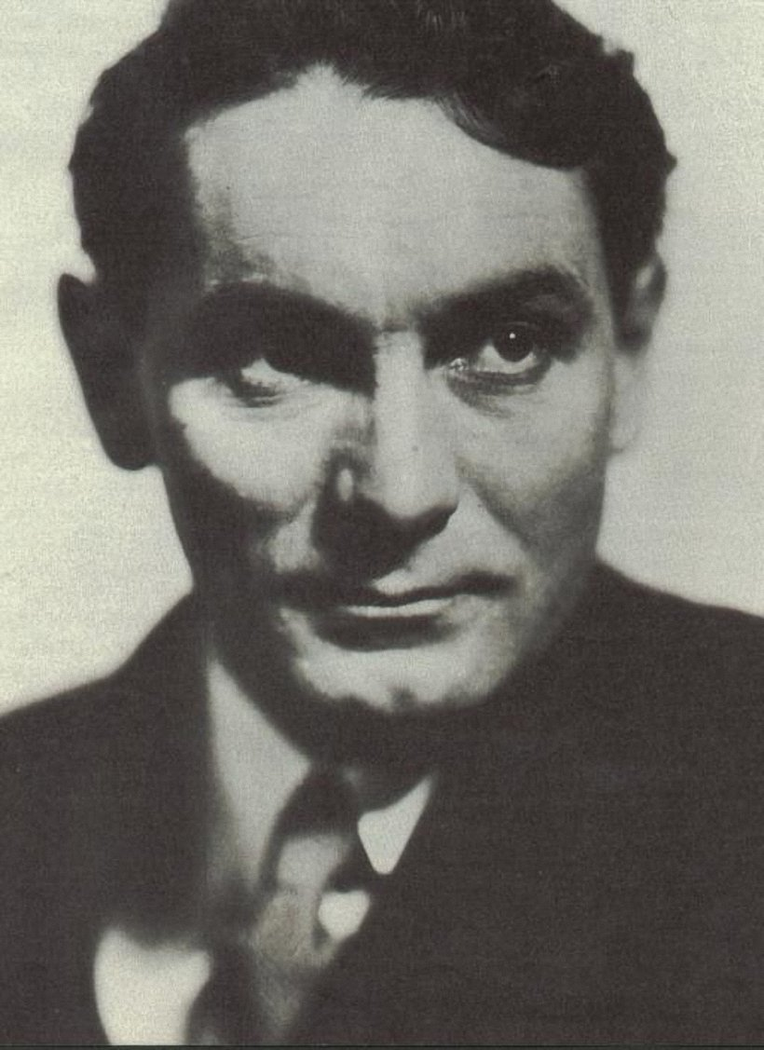**Vsevolod Illarionovich Pudovkin** (16 February 1893 – 30 June 1953) was a Russian and Soviet film director, screenwriter and actor who developed influential theories of montage. Pudovkin's masterpieces are often contrasted with those of his contemporary Sergei Eisenstein, but whereas Eisenstein utilized montage to glorify the power of the masses, Pudovkin preferred to concentrate on the courage and resilience of individuals. He was granted the title of People's Artist of the USSR in 1948.

**Bazin and the New Wave**

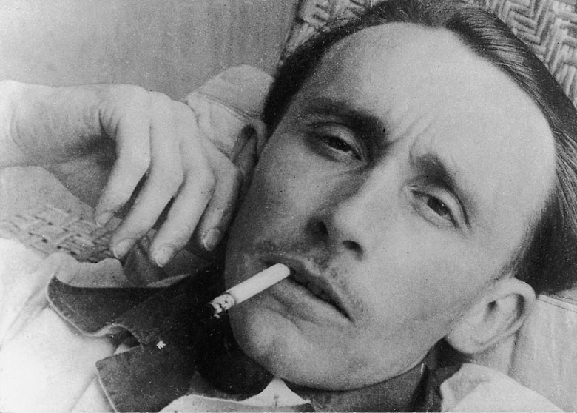 **André Bazin** (French: [bazɛ̃]; 18 April 1918 – 11 November 1958) was a renowned and influential French film critic and film theorist.

Bazin started to write about film in 1943 and was a co-founder of the renowned film magazine Cahiers du cinéma in 1951, along with Jacques Doniol-Valcroze and Joseph-Marie Lo Duca.

Bazin's call for objective reality, deep focus, and lack of montage are linked to his belief that the interpretation of a film or scene should be left to the spectator. This placed him in opposition to film theory of the 1920s and 1930s, which emphasized how the cinema could manipulate reality.

***In popular culture***

François Truffaut dedicated *The 400 Blows* to Bazin, who died one day after shooting commenced on the film.

Jean Renoir dedicated the revival of *The Rules of the Game* to the memory of Bazin.

Richard Linklater's film *Waking Life* features a discussion between filmmaker Caveh Zahedi and poet David Jewell regarding some of Bazin's film theories. There is an emphasis on Bazin's Christianity and the belief that every shot is a representation of God manifested in creation.

Jean-Luc Godard's *Contempt* (Le Mépris) (1963) opens with a quotation wrongly attributed to Bazin (in fact the author of the quotation is French film critic and playwright Michel Mourlet from his article "Sur un art ignoré" in Cahiers du cinéma, no. 98).

David Foster Wallace's novel *Infinite Jest* references Bazin in regard to film and film criticism (page 745 and following).

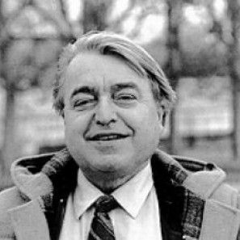**Christian Metz** (1931 –1993) was a French film theorist, best known for pioneering the application of Ferdinand de Saussure's theories of semiology to film. Metz was born in Béziers. During the 1970s, his work had a major impact on film theory in France, Britain, Latin America and the United States.

In Film Language: A Semiotics of Cinema, Metz focuses on narrative structure — proposing the "Grand Syntagmatique", a system for categorizing scenes (known as "syntagms") in films.

Metz applied both Sigmund Freud's psychology and Jacques Lacan's mirror theory to the cinema, proposing that the reason film is popular as an art form lies in its ability to be both an imperfect reflection of reality and a method to delve into the unconscious dream state.

Metz died in Paris, aged 61.

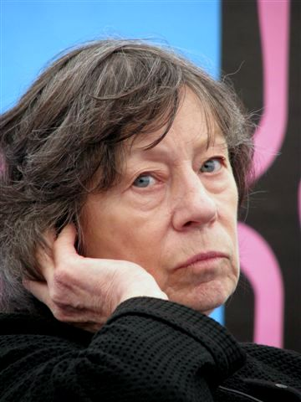**Laura Mulvey** (born 15 August 1941) is a British feminist film theorist. She was educated at St Hilda's College, Oxford. She is currently professor of film and media studies at Birkbeck, University of London. She worked at the British Film Institute for many years before taking up her current position.

Mulvey is best known for her essay & thoughts, 'Visual Pleasure and Narrative Cinema', written in 1973 and published in 1975 in the influential British film theory journal Screen. It later appeared in a collection of her essays entitled Visual and Other Pleasures, as well as in numerous other anthologies. Her article, which was influenced by the theories of Sigmund Freud and Jacques Lacan, is one of the first major essays that helped shift the orientation of film theory towards a psychoanalytic framework. Prior to Mulvey, film theorists such as Jean-Louis Baudry and Christian Metz used psychoanalytic ideas in their theoretical accounts of the cinema. Mulvey's contribution, however, inaugurated the intersection of film theory, psychoanalysis and feminism.

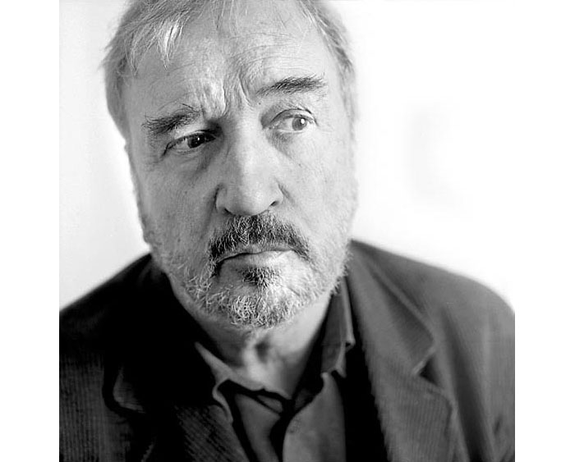**David Bordwell** (born July 23, 1947) is an American film theorist and film historian. Since receiving his PhD from the University of Iowa in 1974, he has written more than fifteen volumes on the subject of cinema including Narration in the Fiction Film (1985), Ozu and the Poetics of Cinema (1988), Making Meaning (1989), and On the History of Film Style (1997).

With his wife Kristin Thompson, Bordwell wrote the introductory textbooks Film Art (1979) and Film History (1994). With aesthetic philosopher Noël Carroll, Bordwell edited the anthology Post-Theory: Reconstructing Film Studies (1996), a polemic on the state of contemporary film theory. His largest work to date remains The Classical Hollywood Cinema: Film Style and Mode of Production to 1960 (1985), written in collaboration with Thompson and Janet Staiger. Several of his more influential articles on theory, narrative, and style were collected in Poetics of Cinema (2007), named in homage after the famous anthology of Russian formalist film theory Poetika Kino, edited by Boris Eikhenbaum in 1927.

**FILM THEORY IN ACADEMIA**

In the 1960s and 1970s, film theory took up residence in academia importing concepts from established disciplines like psychoanalysis, gender studies, anthropology, literary theory, semiotics and linguistics. However, not until the late 1980s or early 1990s did film theory per se achieve much prominence in American universities by displacing the prevailing humanistic, **auteur theory** that had dominated cinema studies and which had been focused on the practical elements of film writing, production, editing and criticism. American scholar **David Bordwell** has spoken against many prominent developments in film theory since the 1970s, i.e., he uses the derogatory term "SLAB theory" to refer to film studies based on the ideas of Saussure, Lacan, Althusser, and Barthes. Instead, Bordwell promotes what he describes as "neoformalism."

During the 1990s the digital revolution in image technologies has influenced film theory in various ways. There has been a refocus onto celluloid film's ability to capture an "indexical" image of a moment in time by theorists like Mary Ann Doane, Philip Rosen and Laura Mulvey who was informed by psychoanalysis. From a psychoanalytical perspective, after the Lacanian notion of "the Real", Slavoj Žižek offered new aspects of "the gaze" extensively used in contemporary film analysis.[5] There has also been a historical revisiting of early cinema screenings, practices and spectatorship modes by writers Tom Gunning, Miriam Hansen and Yuri Tsivian.

In **Critical Cinema: Beyond the Theory of Practice** (2011), Clive Meyer suggests that 'cinema is a different experience to watching a film at home or in an art gallery', and argues for film theorists to re-engage the specificity of philosophical concepts for cinema as a medium distinct from others.