**VINTAGE LENSES - A GUIDE – VER 1.5**

**for DSLR and DIGITAL VIDEO**

**By *Stephen W. DaVega***

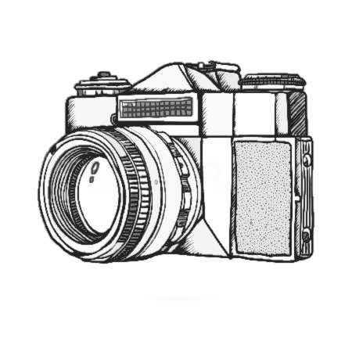FORWARD

This is compilation of information from various sources, including various websites, articles and forums. I put it together because of the amount of time it was taking to wrap my head around all the possibilities and the limitations when it comes to vintage glass. If there are additions or corrections please email them to me at: *stephendavega@gmail.com*

1. 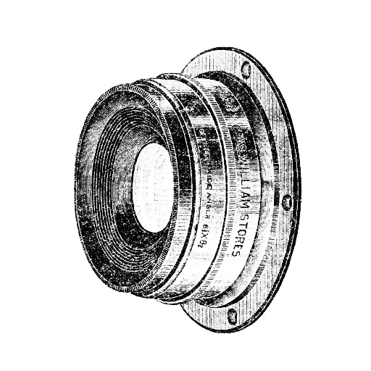What is Vintage Glass?   
   Vintage glass is a reference to the group of lenses from the **MF** (manual focus) era (1890s to 1990s). Though most usable vintage glass will be post World War II. The technologies in the making of glass have changed very little, thus vintage lenses are of often of comparable quality to modern lenses. While not all vintage lenses have good optical quality, a lot of the higher-end lenses are just as amazing as todays higher-end lenses: the only difference being that older high-end lenses are reasonably priced.

**Note:** *Some of these lenses from the 50’s, 60’s and 70’s have little air bubbles in them, but this isn’t a sign of bad glass in fact its quite the contrary. These air bubbles indicate the use of high-end glass: the hotter the glass is when molded, the better the optical quality, but also the more air bubbles there are. These bubbles do not affect the optical quality or focus of the lens.*

2- Advantages of Vintage Glass

1. Smooth, long through focusing, often over 300 degrees of rotation. Rings are bigger, much smoother and the focus throw (the amount of degrees the lenses has to be turned from **MFD** (minimum focusing distance) to infinity is much higher, resulting in being able to make much finer adjustments.
2. Manual lenses always have hard stops at each end of the focusing range (**Canon EF** lenses keep spinning - messing up any follow focus marks).
3. Mechanical (and hence faster) aperture adjustment on the lens (modern lenses are controlled electronically via the camera).
4. Some of these lenses have step-less aperture adjustment, just like Cine lenses, essentially making them low budget cine-style lenses.
5. Manual aperture rings (where available) can usually be de-clicked for smooth aperture control.
6. Build Quality. Solid Metal Construction, less plastic. Pretty much every lens produced before around 1985 is made with metal. Lenses made before 1975 are 100% metal. Soviet made lenses in particular are made durable and heavy.
7. Unique optical performance, “film-like” quality to image, often interesting and smother bokeh and amazing flares. Sometime referred to as “character”(really optical imperfection or glorified optical defects).
8. Price. Often much much cheaper than there AF (auto focus) and CINE counterparts.
9. Good investment (unlike modern glass). Appreciating in value.

3 - Disadvantages of Vintage Glass

* 1. Not all vintage lenses are good. A lot of them have poor sharpness & contrast, a lot of chromatic aberration and vignetting, but so do the modern low-end lenses that still cost mode than a good vintage lens.
  2. Lenses from the 60′s and earlier will generally be uncoated or single-coated and will flare easily.
  3. When shooting stopped down (at higher f-stops) the viewfinder darkens significantly. You can compose your image first and then stop down. On your **LCD** it shouldn’t darken (your camera compensates for it).
  4. Manual focus (this can be an advantage or disadvantage depending on your point of view).
  5. There are very few good older zooms out there.

**Note:** *The first zoom lens dates from the late 50’s zoom lenses have seen a tremendous amount of optical quality increase in the last 20 years. Not until the 80’s was there any zoom lens that was worth getting or that came anywhere near the optical quality of primes. Few can compete with newer, AF lenses (while there are some that trump any AF zoom in terms of IQ (image quality), like Zeiss 35-70.*

* 1. Older Wide Angle lens are extremely expensive.
     1. - Disadvantages of Contemporary/Modern Glass for Video

1. Focus- Auto Focus (**AF**) does not work well on video, creating “breathing” – the slight but noticeable continuous refocusing of lens.
2. F/stop exposure is controlled via camera and can’t be done via lens (no smooth exposure changes during shot).
3. The focus throw of **AF** lenses is often noticeably shorter than manual/vintage lenses.
4. Noise - while zooming. Modern Zooms make a plastic on plastic sound while manual zooming, always noticeable on camera mic, sometimes on shotgun mics.
5. Plastic-y, cheap-y construction.

5 – What Works and What Doesn’t Work?

Each brand of camera has its own idiosyncrasies. What lenses work and which ones don’t for which camera? Here are the basics:

Modern **Nikon** cameras work with most vintage Nikon lenses, but they won’t work with most third-party lenses (like **Olympus, Canon or Pentax**).

Modern Canon and Olympus cameras don’t work with most vintage Canon lenses, but they will work with most third-party lenses (Nikkor, Pentax, Mir, Helios, Carl Zeiss Jena, etc.).

Pentax cameras work with nearly all Pentax lenses, and any third-party lens that uses the Pentax mount.

Sony cameras work with some Minolta lenses and lenses with M42 – (screw) style mounts.

6 – The Brands – The Lenses

a. Nikkor (manual)

* + - Non- AI (auto indexing) (1959-1977) - Non indexing – Good with Canon
    - AI (Auto indexing) (1970s-1980)
    - AIS (Auto Indexing shutter) (1982)

1. Leica
2. Zeiss
3. Carl Zeiss Jena (Zeiss)
   * Sonnar,
   * Biometar
   * 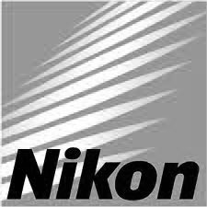Flektogon
   * Opton
4. Mir
5. Mamiya
6. Industar
7. Beroflex
8. Helios
9. Pentax
10. Olympus
11. Pentax
12. Jupiter
13. Tair
14. Carl Zeiss Jena
15. Voigtlander
16. Orestor Meyer-Optik
17. Minolta/Rokkor
18. Vivatar

7 – Types of Mounts – Adaptability.

The Following is list of mounts that are adaptable to the named Camera/Mount Type.

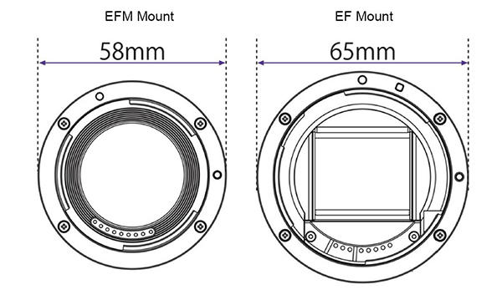

**Canon** (**EOS)** adaptable mounts:

* Nikon (F-mount)
* Pentax (K-mount)
* Pentax Screw (M42)
* Praktica - Screw (M42)
* Olympus (OM-mount)
* Contax/Yashica (C/Y-mount)
* Yashica FR, FX
* Contax RTS
* Contarex
* Petri Bayonet
* Ricoh Bayonet
* Tamron (T/T2 – screw mount. Similar, but not the same as M42)
* Leica R

**Nikon** (**F)** adaptable mounts:

* Older Nikon (F-mount)
* Tamron (T/T2 – screw mount. Similar, but not the same as M42)
* Leica (R-mount. Replacement Mount) not to be confused with M-mount. You can’t adapt M.
* *Many Leica R, Olympus, and certain other lenses can be used on Nikon by replacing the rear mount; this is a modification of the lens itself, not a lens adapter per se. The modification is generally reversible.*

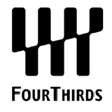**Four Thirds** adaptable mounts:

* + - Olympus OM
    - Olympus MF-1
    - Pentax
    - Contax
    - Leica M
    - Leica R

**Micro 4/3rds** (**MFT**) adaptable mounts:

* + - Olympus OM
    - Olympus MF-2
    - Four-thirds
    - Olympus MMF-1 adapter
    - Panasonic DMW-MA1
    - 4/3 to micro-4/3
    - Leica M
    - Leica Screw Mount
    - Contax G
    - Canon
    - Nikon

**Leica M** (**bayonet**)adaptable mounts:

* Nikon F
* Leica R

**Sony NEX** adaptable mounts:

* Nikon F
* Leica M
* Pentax K

8 – Types of Mounts – History and Details

**Note:** *Most brands have their own mount to attach a lens to a camera, while some used mounts by other manufacturers or made lenses for other camera brands.*

*Much older camera’s used a screw mount that used a thread to screw a lens onto the camera (like M42 or T/T2). Later on, the bayonet replaced the more common screw mounts, because they were easier to use, as well as more secure.*

**Nikon F-mount** -Introduced in 1959, this fitting type is still being used in Nikon digital SLRs. Nikon F-mount can be adapted to EOS cameras. Nikon F-mount lenses can be mounted on Leica M9 cameras using the Novoflex Lens Mount Adapter - Nikon Lens to Leica M Body adapter. Nikon F-mount can be mounted on Sony NEX with a Voigtlander adapter. Not many lenses can be adapter for Nikon, but Nikon has never changed its mount, allowing you to shoot with any Nikon glass that was ever made for a Nikon SLR

**Pentax K-mount** (**bayonet**)-Introduced in 1975, this fitting type is still being used in Pentax digital SLRs. Sometimes referred to as the "PK-mount", is a lens mount standard for mounting interchangeable photographic lenses to 35 mm single-lens reflex (SLR) cameras. It was created by Pentax in 1975, used by all Pentax 35 mm and digital SLRs since; it is also used by the Pentax K-01, a mirrorless interchangeable-lens camera introduced in 2012. A number of other manufacturers have also produced many K-mount lenses and K-mount cameras

**Canon EF-mount** Introduced in 1987, this fitting type is still being used in Canon digital SLRs. Older Canon lenses require adaptors. Many lenses can be adapted to modern Canon EOS cameras. Canon changed their SLR mount two times (first from FL to FD, then from FD to EF), allowing you only to use Canon glass from 1986 or later.

**Minolta Alpha, A or AS-mount**

Introduced in the mid-1980s, this type of fitting was later adopted by Sony and will fit Minolta and Sony Alpha DSLR cameras.

**Minolta MD, MC or SR-mount**

Introduced starting in 1958, these fittings are generally compatible with each other and with vintage, manual Minolta SLRs. They can be used with some DSLR cameras, including Sony and Minolta products, with the use of an adaptor.

**Four Thirds mounts**

This standard is used in a number of modern digital SLRs, including Olympus and Kodak cameras.

**Micro Four Thirds mounts**

The Micro Four Thirds system (**MFT**) is a standard created by Olympus and Panasonic, and announced on August 5, 2008, for mirrorless interchangeable lens digital cameras and camcorders design and development. Unlike Four Thirds, the **MFT** system design specification does not provide space for a mirror box and a pentaprism, allowing smaller bodies to be designed, and a shorter flange focal distance and hence smaller lenses to be designed. The shallow but wide **MFT** lens mount also allows the use of existing lenses including **Leica M, Leica R, and Olympus OM** system lenses, via Panasonic and Olympus adapters. Aftermarket adapters include Leica Screw Mount, Contax G, Canon, Nikon, and Pentax, among others.

The **MFT** system design specifies a new bayonet type lens mount with a flange focal distance of slightly under 20 mm – half as deep as the Four Thirds system design. By avoiding internal mirrors the **MFT** standard allows a much thinner camera body. The flange diameter is about 38 mm, 6 mm less than that of the Four Thirds system. Electrically, MFT uses an 11-contact connector between lens and camera, adding to the nine contacts in the Four-Thirds system design specification. Olympus claims full backward compatibility for many of its existing Four Thirds lenses on **MFT** bodies, using a purpose built adapter with both mechanical and electrical interfaces.

In fact, almost any still camera, movie or video camera interchangeable lens that has a flange focal distance greater than or marginally less than 20 mm can often be used on **MFT** bodies via an adapter. While these so-called "legacy" lenses can only be used in a manual focus, manual aperture control mode on **MFT** cameras, hundreds of lenses are available for use, even those that survive for cameras no longer in production.

Virtually any lens can be used on **MFT** camera bodies, as long as an adapter exists. For instance, Four Third lenses can be used with auto focus using the adapters designed by Olympus and Panasonic.

**Leica R Mount -** The standard method of connecting a lens to the Leica R series of 35 mm single-lens reflex cameras. The mount is descended from those used for the Leicaflex, Leicaflex SL and Leicaflex SL2 SLR cameras, but differs in the cams used to communicate lens aperture information to the camera. 3 cam lenses are compatible with all of the Leica SLR cameras, while R-only lenses have a slightly different mount shape that will not fit on the earlier cameras.

**Leica M mount** is a camera lens mount introduced in 1954 with the Leica M3, and a range of lenses. It has been used on all the Leica M series up to the current film Leica M7 and digital Leica M.

Leica M lenses can be mounted on Sony NEX with a Voigtlander adapter.

**M42** (screw) mount/**Pentax (**screw**)**/**Pentacon/Praktica** It is more accurately known as the M42 × 1 mm standard, which means that it is a metric screw thread of 42 mm diameter and 1 mm thread pitch. It was first used in Zeiss' Contax S of 1949. This is was/is a very common 35mm film camera mount for Russian and German lens/cameras.

**T-mount** (**screw**) is a standard lens mount for cameras and other optical assemblies. The T2 version is a screw mount using a male M42x0.75 metric thread on the lens with a flange focal distance of 55 mm and a mating female thread on a camera adapter or other optical component. This thread form is referred to as T-thread. (This should not be confused with the M42 lens mount, which is also 42 mm, but has a 1 mm thread pitch.) adapter called T/T2-Ring is needed to adapt a T-mount lens to any camera body without optical correction to achieve infinity focus.

**M39 (screw)** lens mount is a screw thread mounting system for attaching lenses to 35 mm cameras, primarily rangefinder (RF) Leicas. It is also the most common mount for Photographic enlarger lenses.

**Contax/Yashica (C/Y Mount)** - Like the first attempt at forging an alliance with Pentax, Zeiss designed a new common lens mount, known as Contax/Yashica mount (C/Y) to be used on cameras bearing both marques.

**Olympus OM System** **(O = Olympus, M = Maitani)** was a line of 35mm single-lens reflex cameras, lenses and accessories sold by Olympus between 1972 and 2002 (some accessories were sold until early 2003). The system was introduced by Olympus in 1972, more than a decade after Nikon, Canon, and other manufacturers had established their own SLR ranges.

*Other Mounts*

**C-Mount** - C mount is a type of lens mount commonly found on 16mm movie cameras, closed-circuit television cameras, machine vision cameras and microscope phototubes. C-mount lenses provide a male thread which mates with a female thread on the camera. The thread is nominally 1.000 inch (25.4 mm) in diameter, with 32 threads per inch, designated as "1-32 UN 2A" in the ANSI B1.1 standard for unified screw threads. The flange focal distance is 17.526 millimeters (0.6900 in) for a C mount.

Merely to say that a lens is "C-mount" says very little about the lens' intended use. Unlike all other lens mounts, each of which is used for only a single format, C-mount lenses have been made for many different formats, the largest being 4 times as large as the smallest. The vast majority of C-mount lenses are built for the 8-mm and 16-mm film formats and the 1/3-, 1/2-, 2/3-, and 1-inch video formats, which corresponds to a range of image circles from 5 to 17 mm diameter, approximately. Some manufacturers have recently introduced lenses for the 4/3 inch / 1.3 inch format but these remain very expensive.

**D-mount** is a type of lens mount commonly found on 8mm movie cameras. Throat or thread diameter 15.88 mm (0.625 inch) Mount thread pitch 32 TPI Flange focal distance 12.29 mm

*Non- Vintage Mounts*

**Sony E-mount** is a lens mount designed by Sony for their NEX ("New E-mount experience"[citation needed]) series of camcorders and mirrorless cameras. Initially this mount is implemented in Sony Alpha NEX-3 and NEX-5 with APS-C sensor size. E-mount integration into Sony camcorder products is provided with the Sony Handycam NEX-VG10.

9 - Flange to Film Distance

The factor that determines whether a lens can be used on your digital camera or not, is the flange to film distance (**FFD**). This is the distance from the rear lens mount of your lens to the cameras the focal plane (film/sensor). This is sometimes referred to as “register distance”.

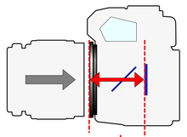

Canon EOS: 44.0mm < short enough to allow many adapters   
Leica R:     47.0mm  
Leica M:       27.95mm   
Nikon F:       46.5mm   
Olympus OM: 46.0m

This is why you can adapt Nikon to Canon, but not Canon to Nikon. Canon’s register distance is shorter. A canon lens on a Nikon would hit the Nikon’s mirror. If the FFD distance for your camera is bigger than that of the lens you want to adapt, you won’t be able to, because the (camera) mirror will hit the rear element of the lens.

Any lens where the register (FFD) distance to it’s designated camera (Canon lens to Canon Camera, Nikon Lens to Nikon Camera, etc.) is longer than that of the camera you are adapting it to (i.e. Nikon to Canon), you should be able to adapt it. You have to take into account the size of the adapter ring though.

Even though the FFD might on paper be big enough, a lot of the older lenses have a rear element that protrudes a little into the camera when focused at infinity. This prevents the mirror in your SLR to move up, because it hits the rear element of camera, thus preventing from taking an image. This mirror clearance issue is one of the reasons why you won’t be able to adapt vintage glass (or you can adapt it, but can’t focus to infinity, resulting in you being able to use only ‘half’ of your lens).

|  |  |  |
| --- | --- | --- |
| **Canon EOS** | **44.0 mm** | **Adapters** |
| Contarex | 46.0 mm | Mechanical adapters with no optics and which maintain infinity focus may be possible |
| Contax RTS | 45.5 mm |
| Leica R | 47.0 mm |
| Nikon | 46.5 mm |
| Olympus OM | 46.0 mm |
| Pentax K | 45.5 mm |
| Pentax Screw (M42) | 45.5 mm |
| Petri Bayonet | 45.5 mm |
| Ricoh Bayonet | 45.5 mm |
| T2 mount | 55.0 mm |
| Yashica FR, FX | 45.5 mm |
| Canon (FD and earlier) | 42.0 mm | Adapters would need optics for infinity focus and act as weak multipliers |
| Fujica X Mount (bayonet) | 43.5 mm |
| Konica F | 40.5 mm |
| Minolta MD | 43.5 mm |
| Miranda | 41.5 mm |

**FFD/Register Distances (*Canon*)**

**FFD/Register Distances (*Nikon*)**

|  |  |  |
| --- | --- | --- |
| Nikon | 46.5 mm | **Adapters** |
| Nikon F | 46.5 mm | No adapter |
| T2 mount | 55.0 mm | Mechanical adapter with no optics and which maintain infinity focus may be possible |
| Leica R | 47.0 mm | Original Mount can be replaced with Nikon F |
| Olympus OM | 43.5 mm |

10 - Adapters

A lens adapter requires some thickness to adapt a lens to a camera body. Generally speaking, a minimum of 2mm is required.

For a lens adapter to allow infinity focus, its thickness must match the difference in flange focal distance.

* Nikon F 46.5mm to Canon EOS 44.0mm = adapter of 2.5mm

**List of know Mechanical adapters (no optics)**

**Note:** All EF series adapters will work on EF-S, but EF-S adapters will not work on full frame bodies without risking damage to the reflex mirror.

* Bronica ETR medium format
* Bronica SQ medium format
* Contax/Yashica SLR
* Hasselblad medium format
* Leica R
* Leica Visoflex
* Mamiya 645 medium format
* Nikon F Lenses with Aperture Rings
* Nikon G (and non G) Lenses without Aperture Rings
* Olympus OM
* Pentax 42 Screw Mount
* Pentax K (to EF-S)
* Pentax PDA (to EF-S)
* Pentax 645 medium format
* Pentax 67 medium format
* Tamron Adaptall
* T-mount

11 – Adapters, Sensors and Issues

Full frame sensor cameras have a bigger mirror than crop camera’s (while often having the same **FFD** – like Canon) some lenses can only be adapted to crop frame sensor, while the Full Frame camera’s won’t have mirror clearance.

Full Frame vs. Crop Frame

Nikon has two different sensor sizes

* 35mm (FX) i.e. “full frame”
* 1.5x (DX) i.e. “cropped frame” (sometimes referred to as "focal length multiplier")

Canon has three sensor sizes:

* 35mm i.e. “full frame”
* 1.3x (APC-H) i.e. “cropped frame” (sometimes referred to as "focal length multiplier")
* 1.6x. (APS-C) i.e. “cropped frame” (sometimes referred to as "focal length multiplier")

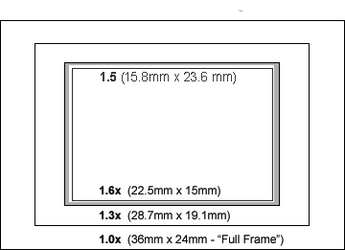

You can buy an optical adapter to prevent the mirror from hitting and allowing you to use lenses with a shorter FFD than the camera’s (e.g. Canon to Nikon) but those adapters GREATLY decrease the optical quality of your lenses, making it pointless to do so.

**Notes:** *While* ***Minolta/Sony*** *uses an* ***FFD*** *of 44.5 (0.5mm bigger than Canon) it can’t be adapted because of issues with mirror clearance.*

*Most* ***Minolta (Rokkor)*** *lenses can be converted to the* ***EF mount*** *though (changing the mount, not adapting it).*

*Because of the mirror and super short* ***FFD****, any lens that was made for an SLR can be adapted to mirrorless cams.*

*Though it looks like* ***Pentax K-mount*** *lenses should be adaptable to an EOS body if you just consider the flange to focal plane distance of PK lenses, it turns out that the diaphragm coupling lever which sticks out from the back of the lens causes problems. On most EOS bodies you would have to remove this lever.*

***APS-C Sensor*** *EOS bodies which can take* ***EF-S*** *lenses [all after the EOS 10D) can take adapted* ***Pentax-K*** *lenses without the need to remove the aperture coupling lever. There’s more room inside the* ***EF-S*** *capable body and the reflex mirror of APS-C sensor cameras is smaller, so there's less chance of interference.*

10 – SPECIFIC LENSES – THE GOOD THE BAD AND THE UGLY

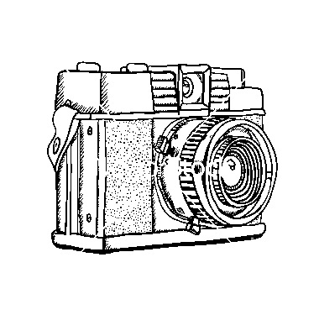Note: MC denotes multi-coating to reduce lens flare and haze.

***Nikkor (Japanese)***

Nikon 18mm f2.8 AF-D

Nikon 20mm f2.8 AF

Nikon 24mm f2.8 AF-D

Nikon 35mm f2 AF-D

Nikon 50mm f1.8 AF-D

Nikon 85mm f1.8 AF-D

Nikon 105mm f2 DC

Nikon 135mm f2 DC

Nikon 80-200 AF-D

***Russian***

Mir-20M 20mm F3.5 prime lens (m42 mount)

Mir-24H 35mm f2.0

Volna-9 50 2.8 macro

Helios 44-2 58mm f 2.8 (m42 mount)

Helios 40-2 85mm f1.5

Helios 44M-6 58mm f2.0

Helios 40-2 85mm f1.5

Helios 77M-4 MC 50mm f1.8

Jupiter 6-2 180mm f2.8

Jupiter-9 85mm/f2.0 (Pentax Screw)d

Tair 11A 135mm f/2.8

Zenitar 16/2.8 fisheye (Pentax Screw)

***German***

Carl Zeiss Jena Biometar 120mm F/2.8

Carl Zeiss 28mm F/2.8 Distagon - CONTAX

Meyer Goerlitz Trioplan 100mm F/2.8

Meyer-Optik Görlitz Lydith 30mm F/3.5

Porst 35mm F1.8

Porst 135mm F1.8

Porst Weitwinkel MC Auto F 35mm F/2.8 M42

Porst Cosina MC 55mm F/1.2

Carl Zeiss 25mm Distagon T* F2.8

Carl Zeiss 28mm Distagon T* F2.8

Carl Zeiss 28mm Distagon T* F2.0

Carl Zeiss 35mm Distagon T* F2.8

Carl Zeiss 50mm Planar T* F1.4

Carl Zeiss 85mm Planar T* F1.4

Carl Zeiss 135mm Sonnar T* F2.8

Carl Zeiss 200mm Teletessar T* F3.5

Carl Zeiss 20mm Flektogon MC F2.8

24mm Kiron Kino F2.0

35mm Flektogon MC F2.4

50mm Pancolar MC F1.8

Pancolar MC 80mm F1.8

Sonnar MC 135mm F3.5

**Japanese/Korean/Chinese**

Super Takumar 50mm f1.4

Super-Multi-Coated Takumar 50mm 1.4

Minolta MC 58mm f1.2 Rokkor

Mamiya Sekor 55mm f1.4

Sirius MC f2.8

Ricoh Rikenon XR 50mm F1.4

Yashica Yashinon DS 50mm f/1.4

Peleng 8/3.5 fisheye (Pentax Screw)

Tamron 17/3.5 (Tamron Adaptall mount)

Tamron 24/2.5 (Tamron Adaptall mount)

Tamron 28/2.8 (Tamron Adaptall mount)

Tamron 500/8 Mirror (Tamron Adaptall mount)

Asahi Optical (Pentax) Takumar 18mm Fisheye (M42) f/11

**American (sort of)**

Vivitar 19/3.8 (Pentax Screw)

Vivitar 24 mm F 2.8

Vivitar (Kiron) 24mm f2 (Nikon AI mount)

Vivitar 28mm f2.0

Vivitar 90mm f2.5 macro

Vivitar 500/8 mirror (T-Mount)

Olympus Zuiko 50mm f1.8

Olympus Zuiko 28mm f3.5

Olympus Zuiko 24mm f2.8

Olympus Zuiko 21mm f3.5

Zenitar 16mm f2.8

Pentax-M SMC Takumar 50mm f1.4

Pentax Super Takumar 35mm f/2 -

Pentax 55/2.0 (Pentax Screw)  
 SMC Pentax 28mm f3.5

Pentacon 135/2.8 (Pentax Screw)

Soligor 35/2.8 (T-Mount)

Various telescopes (T-Mount)

**11 -RESOURCES**

Vintage Lenses for Video

<http://www.vintagelensesforvideo.com>

135mm Lens comparisons

<http://oomz.net/135/>

Manual Focus Lens Reviews/Info

<http://www.mflenses.com>

B&H - Mirrorless Cameras

<http://www.bhphotovideo.com/indepth/photography/hands-reviews/use-m-mount-and-m42-lenses-mirrorless-cameras>

Listed all the flange distances, check it out here:

<http://en.wikipedia.org/wiki/Flange_focal_distance>

List of Camera Mounts and Registers (Focal Flange Distances)

<http://www.markerink.org/WJM/HTML/mounts.htm>

Russian Lens for Sale

<http://top35mm.com/>

Manual Lenses for Canon

<http://www.bobatkins.com/photography/eosfaq/manual_focus_EOS.html>

Zeiss Medium Format Lenses

<http://frankglencairn.wordpress.com/vintage-zeiss-glass-on-modern-cameras/>