Robert L Mott's/DaVega's

**10 Components of Sound**

Listed below are nine components that most influence how sound effects are perceived. By modifying or eliminating any one or a combination of these components, the sound effects are changed or totally new sounds are created.

**"Music components":**

***1.Pitch***

***2. Timbre***

***3. Harmonics***

***4. Loudness***

***5. Rhythm***

**"Sound envelope components":**

***6. Attack***

***7. Decay***

***8. Sustain***

***9. Release***

**"Record and playback component":**

**9. Speed**

**THE MUSICAL COMPONENTS**

**1. PITCH**

*The pitch of a sound is determined by the frequency of the sound. Normally we refer to its pitch.*

*Frequencies are grouped as ..*

*low (bass) - sounds of thunder and gunshots*

*midrange - a telephone ringing*

high (treble) - small bells and cymbals

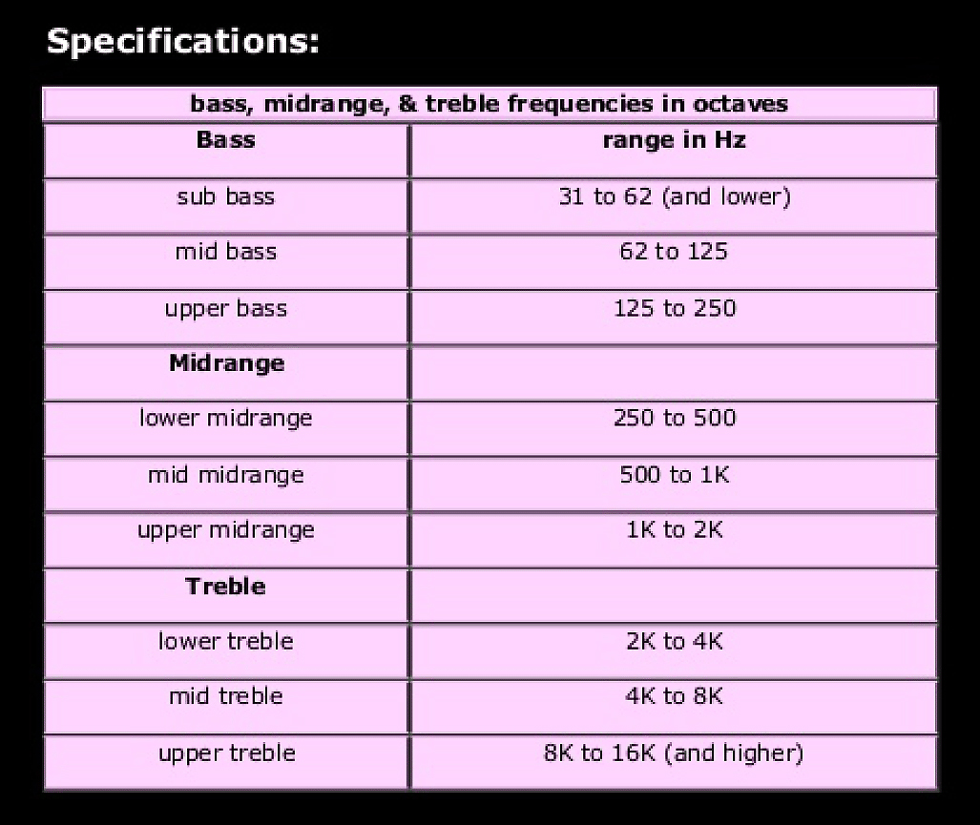

**Low frequencies** make the sound powerful and warm

**Midrange frequencies** give sound its energy.

**Humans are most sensitive** to midrange frequencies.

**High frequencies** give a sound its "presence" and life like quality.

Presence of a sound enables us to hear it clearly and gives us the feeling

that we are close to its origin.

**2. TIMBRE**

Timbre is that unique combination of fundamental frequency, harmonics, and overtones that gives each voice, musical instrument, and sound effect its unique coloring and character (Color or tone distinct from its pitch and intensity (amplitude). When we call someone's voice nasal or certain musical tone mellow, we are referring to timbre.)

***02 Timbre Video>>>***

**3. HARMONICS (overtones)**

When a object vibrates it propagates sound waves of a certain frequency. This frequency, in turn, sets in motion frequency waves called harmonics.

The basic frequency and its resultant harmonics determine the timbre of a sound. The greater the number of harmonics, the more interesting is the sound that is produced.

It is an object's ability to vibrate and set up harmonics that determines the pleasantness of the resultant sound. Crystal glass set up harmonics that are more pleasant than harmonics of ordinary glass.

The combination of fundamental frequency and its harmonics is a complex wave form.

***03 Harmonics Videos>>>***

**4. LOUDNESS**

The loudness of a sound depends on the intensity of the sound stimulus. The amplitude, or breadth, of vibrations produces our sense of loudness, or volume. A dynamite explosion is loader than that of a cap pistol because of the greater amount of air molecules the dynamite is capable of displacing. Loudness becomes meaningful only if we are able to compare it with something. The sound of a gunshot may be deafening in a small room, but actually go unnoticed if fired in a subway station when a train is roaring past.

"Equal loudness"

Humans are most sensitive to frequencies in the midrange ***(250 Hz - 5000 Hz)***

Perceptual Coloring/Loudness - When two sounds, a bass sound and a middle range sound are played at the same decibel, the listener perceive the middle range sound to be louder.

This is why a clap of thunder in a horror movie may contain something so unweatherlike as a woman's scream.

Loudness is also related to perceived distance; often the loader the sound, the closer we take it to be.

***04. Loudness Wars Video >>>>>***

Monitoring Standards in Music no!! In film YES

**DB FS VS DB SPL**

**85db spl, 82db spl, 79db spl**

**04. Pink Noise >>>>>>**

**5. RHYTHM**

Rhythm is on of the most complex features of sound. Rhythm involves a beat or pulse a pace or tempo and a pattern of accents or stronger or weaker beats.

Music has rhythm

Speech has rhythm

Sound effects have rhythm (e.g. rhythmic qualities)

Images have rhythm

"Mickey Mousing"

A prototype of close coordination between screen movement and sound comes in the animated films of Walt Disney in the 1930s. Mickey Mouse and the other Disney characters often move in exact synchronization with music, even when they are not dancing. Such matching of nondance movement with music came to be known as "Mickey Mousing"

***05. Latin Rythyms >>>>>>***

***05. Mickey Mouse Video >>>>***

**ENVELOPE OF SOUND**



1. Attack

2. Decay

3. Sustain

4. Release

**6. ATTACK**

The way a sound is initiated is called attack. There are two types of attack: fast, slow

*Fast attack*

The closer the attack of a sound (A) is to the peak (begging of D) of a sound, the faster its attack is.



Sounds that have a fast attack are..

gunshots

slaps

door slams

*Slow attack*

Sounds that have a slow attack take longer to build to the decay and sustain level.

Sounds that have a slow attack are…

a dog's short warning growl prior to bark

stepping on a dry leaf

slowly tearing a sheet of paper

closing a door slowly

an entire thunderclap



The entire thunderclap has a time span of approximately five seconds.

By starting the sound at point A, the audience is prepared for the impending thunderclap.

To have a frightening sudden clap of thunder, the slow attack has to be changed to a fast attack.

**Thunderclap Video >>>>**

**7. DECAY**

The decrease in amplitude when a vibrating force has been removed is called decay. The actual time it takes for a sound to diminish to silence is the decay time. How gradual this sound decays is its rate of decay.

Listening to a sound tells if it is...

Indoors (small enclosed area with a great deal of absorbency)

- little decay and with very little or no reverberation

outdoors (open unconfined area)

- long decay with an echo

The end of a sound is often referred to as the "tail" of a sound, and conversely, the beginning of a sound is its "head"

**8. SUSTAIN**

Once a sound has reached its peak, the length of time that the sound will sustain is dependent upon the energy from the source vibrations. When the source sound stops, the sound will began to decay.

The period of time during which the sound is sustained before it begins to fade out.

**9. RELEASE**

The final fade or reduction in amplitude over time.



**9. ADSR >>>>>**

**10. What is the envelope? >>>>**

**"Record and playback component":**

**SPEED**

By increasing or decreasing the playback speed you can change the properties of a sound effect.

Played at twice as fast as the recorded speed ..

a explosion will sound like a gunshot

a voice will sound like the cartoon chipmunk character

**PAL speed-up (4%)**

Motion pictures are typically shot on film at 24 frames per second. When telecined and played back at PAL's standard of 25 frames per second, films run about **4%** faster. This also applies to most TV series that are shot on film or digital 24p.[3] Unlike NTSC's telecine system, which uses 3:2 pulldown to convert the 24 frames per second to the 30 fps frame rate, PAL speed-up results in the telecined video running 4% shorter than the original film as well as the equivalent NTSC telecined video.

Depending on the sound system in use, it also slightly increases the pitch of the soundtrack by 70.67 cents (0.7067 of a semitone). More recently, digital conversion methods have used algorithms which preserve the original pitch of the soundtrack, although the frame rate conversion still results in faster playback.

Edited excerpts

p 53 -70 "What is a sound effect?"

Robert L Mott: Sound effects, Radio, TV, and Film

Robert L Mott: SOUND EFFECTS - Radio, TV, and Film

are available at Internet book stores as Amazon books

Recommended!