HISTORY OF WIDESCREEN ASPECT RATIOS

ACADEMY FRAME   | In 1889 Thomas Edison developed an early type of projector called a Kinetograph, which used 35mm film with four perforations on each side. The frame area was an inch wide and three quarters of an inch high, producing a ratio of 1.37:1.  1932 the Academy of Motion Picture Arts and Sciences made the Academy Ratio the standard Ratio, and was used in cinemas until 1953 when Paramount Pictures released Shane, produced with a Ratio of 1.66:1 on 35mm film.

TELEVISION FRAME  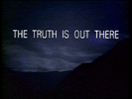 | The standard analogue television screen ratio today is 1.33:1. The Aspect Ratio is the relationship between the width and height. A Ratio of 1.33:1 or 4:3 means that for every 4 units wide it is 3 units high (4 / 3 = 1.33).

CINERAMA  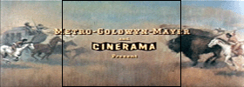 | In the 1950s, Hollywood's attempt to lure people away from their television sets and back into cinemas led to a battle of screen sizes. Fred Waller of Paramount's Special Effects Department developed a large screen system called Cinerama, which utilised three cameras to record a single image. Three electronically synchronised projectors were used to project an image on a huge screen curved at an angle of 165 degrees, producing an aspect ratio of 2.8:1. This Is Cinerama was the first Cinerama film released in 1952 and was a thrilling travelogue which featured a roller-coaster ride. See Film Formats.

CAMERA 65 ULTRA PANAVISION  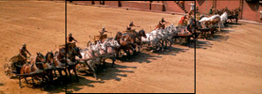 | In 1956 Metro Goldwyn Mayer was planning a massive remake of their 1926 silent classic Ben Hur. Widescreen systems were still new and they drew audiences. MGM wanted to film Ben Hur in the best available system . MGM approached Robert Gottschalk, the president of Panavision, Inc., and asked him to design a system that did not suffer the distortions created by the anamorphic lens. The result was Camera 65 later changed to Ultra Panavision 70.

CINEMASCOPE - 55  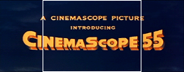 | 20th Century Fox experimented with other anamorphic formats and in 1956 released Carousel which was originally shot on CinemaScope 55 using 55mm film and reduced to anamorphic 35mm.

CINEMASCOPE - PANAVISION  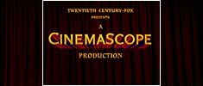 | The Robe was the first film released with a new system called CinemaScope in 1953. Developed by Professor Henri Chretien and copyrighted by 20th Century Fox, the CinemaScope image was photographed on standard 35mm film with an Anamorphic Lens. When projected in the cinema through another anamorphic lens, it produced a ratio of 2.35:1 and a screen size that was two and a half times the size of the conventional screen aspect ratio of 1.33:1. CinemaScope, or Panavision as it is now called, is the most common format shown in cinemas today.

TODD-AO   | In the early 1950s producer Michael Todd, one of the original partners of Cinerama, played an important role in Hollywood's widescreen rush in the wake of TV competition. With movie mogul Joseph Schenck he announced the formation of the Magna Corporation. Together they exploited the 65mm widescreen process and developed a system named Todd-AO. Todd-AO is a 70mm film process with a ratio of 2.20:1and six track magnetic stereophonic sound. It projected faster than the normal at 30 frames per second rather than 24 frames per second. Their first production was Oklahoma released in 1955.

METROSCOPE  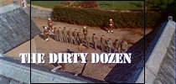 | Many film companies experimented with Widescreen formats, In 1958 Metro Goldwyn Mayer produced Dunkirk in 70mm with an aspect ratio of 2.1, and in 1967 The Dirty Dozen.

WIDESCREEN   | After the introduction of anamorphic systems such as CinemaScope, the standard academy ratio of 1.37:1 was widened. This was simply a matter of masking the top and bottom of a standard academy frame to produce a ratio of 1.85:1 called Widescreen. It is the standard screen format used in cinemas today.

DIGITAL TELEVISION   | Digital Television was introduced in 2001 providing the viewer with a more enhanced picture and sound quality than previously available. One of the most interesting features of Digital Television is the shape. Movies shown in the cinema are filmed in a variety of large screen ratios, but the most common is Panavision 2.35:1. When these movies are shown on TV or VHS tape they do not appear the way they were shown in the cinema. This is because the TV aspect ratio is smaller than the ratios in the cinema, as shown by the diagram on the left. Digital Television has a ratio of 1.78:1 or 16:9 as it is commonly known. This ratio was chosen to be the best compromise to show widescreen movies on television.

The Movie Frames on this page are for demonstration purposes only and are in no way intended to infringe copyright.
All trademarks are the property of their respective holders.

